Basic Training

FT NavVision©

Day 1

Version 1.1 ● December 23, 2013

Topology, network, interface, system configuration, platform hardware and software and basic Wago.

**Last edited: 23 December 2013**

**Copyright © 2011 FT NavVision© . All rights reserved.**

**No part of this publication may be reproduced, transmitted, transcribed, stored in a retrieval system, or translated into any language, in any form or by any means, electronic, mechanical, photocopying, recording, or otherwise, without prior written permission FT NavVision© .**

**All copyright, confidential information, patents, design rights and all other intellectual property rights of whatsoever nature contained herein are and shall remain the sole and exclusive property of FT NavVision© . The information furnished herein is believed to be accurate and reliable.**

**However, no responsibility is assumed by FT NavVision© for its use, or for any infringements of patents or other rights of third parties resulting from its use.**

**The FT NavVision© name and FT NavVision© logo are trademarks or registered trademarks of FT NavVision©**

**All other trademarks are the property of their respective owners**

|  |  |
| --- | --- |
| Publication type: | Training |
| Publication number: | FTT1301001 |
| Title: | Basic training FT NavVision® day 1 |
| Subject: |  |
| Issue: | 1.1 |
| Publication date: | February 21, 2013 |
| Total number of pages: |  |
| Author: |  |

Inhoud

1. Introduction 10

1.1 AMCS architecture 10

1.2 How does it work 12

1.3 Data flow 12

2. Topology 13

2.1 Screens and PC’s 14

2.2 What information do you need and how to get it 16

2.2.1 New build 16

2.2.2 Refit 16

2.3 Topology drawing 17

3. Network 17

3.1 Introduction 17

3.2 Ring network 18

3.3 Materials 19

4. Interfaces 19

4.1 Introduction 19

4.2 Sorts of interfaces 19

4.3 Documentation 20

5. System Configuration 20

5.1 Introduction 20

5.2 Taskbar 21

5.2.1 Taskbar development 21

5.3 Tools 21

5.4 Users 1 21

5.4.1 User name 22

5.4.2 Login at startup 22

5.4.3 Password 22

5.4.4 Rights 22

5.4.5 Add / Remove 24

5.5 Field settings 25

5.5.1 Alarm 26

5.5.1.1 Alarm levels 26

5.5.1.2 Inhibit Properties 27

5.5.1.3 Auxiliary Properties 28

5.5.2 Min/Max 29

5.5.2.1 Instrument range 29

5.5.2.2 Setpoints 30

5.5.2.3 Setpoint delays 31

5.5.2.4 Decimals 31

5.5.2.5 Default unit 31

5.5.2.6 Filter 31

5.5.3 Pulse/Request time 31

5.5.3.1 Tune table 32

5.5.3.2 Result 33

5.5.3.3 Sender 33

5.5.4 Comment 34

5.5.4.1 Group label 34

5.5.4.2 Group label logbook 34

5.5.4.3 Field label 34

5.5.4.4 Field label instrument 34

5.5.5 Auto Switch 35

5.5.5.1 General 35

5.5.5.2 Autoswitch Method 35

5.5.6 Log 36

5.5.6.1 Logging 36

5.5.6.2 Time indication 36

5.5.6.3 Interval 36

5.5.6.4 Filename 37

5.6 Alarm stations 37

5.6.1 Station Matrix 37

5.6.1.1 This station 37

5.6.1.2 Is fallback for 38

5.6.1.3 Show all alarm stations 38

5.6.1.4 Alarm group rights/Duty alarm rights 38

5.6.1.5 Adjustments 38

5.6.1.6 How to set 39

5.6.1.7 Background 40

5.6.1.8 Duty alarm rights 40

5.6.2 Alarm Panels 41

5.6.3 Alarm groups 42

5.6.4 Alarm Settings 43

5.7 Preferences 44

5.7.1 General 44

5.7.2 System Settings 45

5.7.3 Field Settings 45

5.7.4 Ship heading reference 46

5.7.5 SMS service (ship name) 46

5.7.6 SMS service (phone active A,B,C and D) 46

5.7.7 SMS service (SMS PIN) 46

5.8 Taskbar 46

5.8.1 General 46

5.8.1.1 48

5.9 GPS/NMEA 48

5.9.1 General 48

5.9.2 GPS calculates the position in/The position is shown in 48

5.9.3 Trace of received NMEA data 48

5.10 Configuration 48

5.10.1 General 48

5.11 License 49

6. Platform hardware 49

6.1 Serial 49

6.2 General 49

6.3 COM ports 49

6.3.1 COM port assignment 51

6.4 Serial LAN ports 54

6.5 Serial LAN server 55

6.5.1 Type (Moxa UC-711X) 55

6.5.2 Type (V-Linx ESR-904) Obsolete 56

6.5.3 Type (ICPdas i7540D) 57

6.6 CAN ports 58

6.7 Overview connected devices 60

6.8 IP-Address standardization 61

7. Wago 61

7.1 General 61

7.2 Adding a field to the Wago 63

7.3 Wago “Type” explanation 64

7.3.1 Type and behavior 65

7.3.1.1 Alarm 65

7.3.1.2 Alarm Buzzer 65

7.3.1.3 Alarm Status 66

7.3.1.4 Auto 66

7.3.1.5 Closed 66

7.3.1.6 Failure 66

7.3.1.7 High 66

7.3.1.8 High Level 66

7.3.1.9 Impulse 66

7.3.1.10 Lamp 66

7.3.1.11 Low 66

7.3.1.12 Low Level 67

7.3.1.13 Off Lamp 67

7.3.1.14 On Lamp 67

7.3.1.15 Open 67

7.3.1.16 Pending 67

7.3.1.17 Pulse 67

7.3.1.18 Push 67

7.3.1.19 Ready 67

7.3.1.20 Remote 67

7.3.1.21 Request 67

7.3.1.22 Reset (Request) 67

7.3.1.23 Running 68

7.3.1.24 Running Hours 68

7.3.1.25 Set (Request) 68

7.3.1.26 Standard 68

7.3.1.27 Standby 68

7.3.1.28 Status 68

7.3.1.29 Switch 68

7.3.1.30 Timeout 69

7.3.1.31 Too High 69

7.3.1.32 Too High Level 69

7.3.1.33 Too Low 69

7.3.1.34 Too Low Level 69

7.4 Wago Device Manager 70

Figures

Figure 1‑1: AMCS block diagram 11

Figure 1‑2: Field Data Package 12

Figure 2‑1: topology 1 14

Figure 2‑2: topology 2 15

Figure 2‑3: topology 3 16

Figure 2‑4: topology drawing 17

Figure 3‑1: System layout 18

Figure 4‑1: Overview (MOXA) 19

Figure 4‑2: Pin assignment 20

Figure 5‑1: FT NavVision® taskbar 21

Figure 5‑2: Users 22

Figure 5‑3: Rights 23

Figure 5‑4: Add / Remove 24

Figure 5‑5: Field settings 25

Figure 5‑6: Alarm settings 26

Figure 5‑7: Alarm example 27

Figure 5‑8: Inhibit Properties 27

Figure 5‑9: Inhibit When 28

Figure 5‑10: Inhibit When 2 28

Figure 5‑11: Min/Max settings 29

Figure 5‑12: Engine 1 oil pressure indicator (0 - 30 bar) 29

Figure 5‑13: Instrument pointers 30

Figure 5‑14: setpoints 30

Figure 5‑15: Setpoint delays 31

Figure 5‑16: Default unit 31

Figure 5‑17: Tune table 32

Figure 5‑18: Sender box 33

Figure 5‑19: Comment 34

Figure 5‑20: Autoswitch 35

Figure 5‑21: Auto Switch Conditions 35

Figure 5‑22: Auto Switch condition 36

Figure 5‑23: Logging 36

Figure 5‑24: Alarm stations 37

Figure 5‑25: Alarm station settings 39

Figure 5‑26: Select by dragging 39

Figure 5‑27: Duty alarm rights 40

Figure 5‑28: Alarm Panels 42

Figure 5‑29: Alarm Groups 43

Figure 5‑30: Alarm Settings 44

Figure 5‑31: Preferences 45

Figure 5‑32: Taskbar menu 47

Figure 5‑33: License 49

Figure 6‑1: COM ports 50

Figure 6‑2: Drop-down menu (device interfaces) 51

Figure 6‑3: COM port assignment 52

Figure 6‑4: additional configuration 52

Figure 6‑5: Comm Port Settings 53

Figure 6‑6: Serial LAN ports 54

Figure 6‑7: Type (Moxa) 55

Figure 6‑8: Type (V-Linx ESR-904) 56

Figure 6‑9: Type (ICPdas i7540D) 57

Figure 6‑10: Interface 58

Figure 6‑11: Standard 58

Figure 6‑12: Overview connected devices 60

Figure 7‑1: Wago configuration 62

Figure 7‑2: Wago expanded view 63

Figure 7‑3: Sensor-window 64

Figure 7‑4: Sensor type list 65

Figure 7‑5: Wago Device Manager 70

Figure 7‑6: Device Manager 71

Figure 7‑7: Operating mode switch (Wago) 72

Tables

Table 1‑1: Static and dynamic data 12

# Introduction

FT NavVision® Alarm Monitoring and Control System (AMCS) is responsible for the full-time alarm, monitoring & control of a ship’s platform. That is, the actual status of platform objects is monitored and verified against a desired state. In case of undesirable platform behavior the AMCS will notify the operator by issuing an alarm via the Human Machine Interface (HMI). Moreover if the alarm endangers critical systems then the AMCS is able to react via the operator. This means that AMCS is able to control the relevant platform object to prevent further damage and alternately control another platform system (if applicable) to recover. This is known as the automation control level.

In addition, AMCS supports remote platform control by operators. It is possible to control an actuator on the platform from an AMCS Workstation by issuing relevant controls. The AMCS supports several hierarchical operating levels of the various platform systems:

* **Remote control**   
  The AMCS offers remote control of equipment and platforms per Workstation by setup. This remote AMS control can be both open-loop manual control, and closed-loop automatic control.
* **Supervisory control level (management facilities)**  
  Support facilities are provided for manipulating the configuration of the AMCS in terms of operator tasks and availability of components etc. This cannot be performed by a normal operator, but must be done by an authorized operator.

## AMCS architecture

The Alarm Monitoring and Control System (AMCS) is primarily used to monitor a ship’s platform (see Figure 1‑1). Platform statuses and alarms are to be visualized to the AMCS operators via the Human Machine interface (HMI). Besides this operators are able to control the platform via the HMI.

The HMI is based on integrated software that runs on each Workstation. Depending on the configuration, the software can act as a server, client or alarm viewer. For the scope of the type approval process, all Workstations are configured to be an AMCS server.

An AMCS server periodically gathers platform data from each Local Processor Unit (LPU) via the Local Area Network (LAN) and stores it in its local memory. The network topology is fail-safe. Each I/O (Input/Output) station has two network connections and two power sources. Whenever a Workstation needs certain data to visualize platform statuses then it will request the AMCS server for this data. As a result the AMCS server will broadcast the data in concern via the LAN. The server, or fail-safe client with the current master role and up and running is responsible for the central alarm management and control. All workstations can monitor equipment.

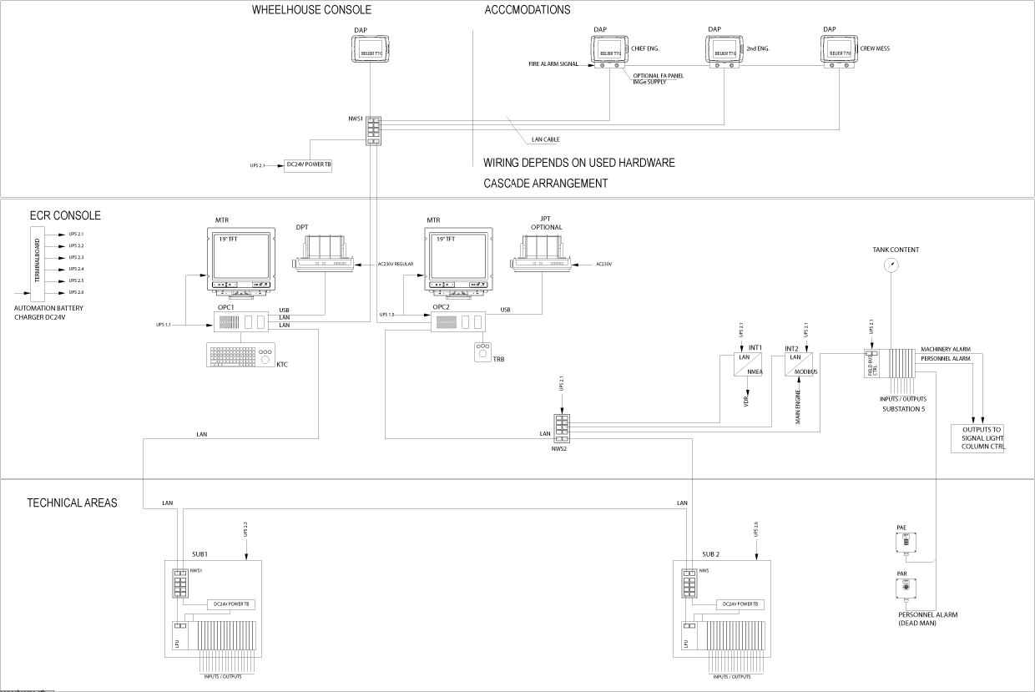

Figure ‑: AMCS block diagram

Since any failure of either the Workstation or LAN is likely to disturb the transfer of data from the platform to the AMCS operator or vice versa all these sub‑systems shall feature redundancy to achieve graceful system degradation.

AMCS server redundancy is achieved by installing two computers each of them capable of running the FT NavVision® software in server mode. Whether the server is master or the fail-safe client is determined by which server is up and running. When the server is up and running, it always be the master. Though as well the server as the fail-safe client is able to serve all the AMCS clients, only the workstation that performs the master role actually will host them. The fail-safe client automatically takes over the master server role in case the master AMCS server unexpectedly goes to offline.

Whenever an AMCS operator originates controls for a certain platform object from his workstation then relevant control signals will immediately be sent over to all workstations via the LAN. However only the master AMCS server will forward the commands to the local Processing Unit (LPU) involved with the processing of that platform object.

Each workstation will be equipped with at least one Thin Film Transistor (TFT) monitor (MTR) and trackball (TRB). Optionally a keyboard trackball combination (KTC) can be applied.

Each workstation will be equipped with two network interface cards both acting as a team in a switch fault tolerant mode. As each out of both network connections will be connected to a unique Ethernet switch (SW1 and SW2) a redundant connection to the LAN is achieved.

## How does it work

FT NavVision® uses a distributed database which is present in the memory of each Workstation which is configured as a server. All sensor data and settings are stored in this database.The database is continuously synchronized with other workstations, with an update rate of 10 times per second.

Data is stored and used based on its timestamp. That means that FT NavVision® uses the data with the latest timestamp. If one server would fail, i.e. because of a broken network link, the newest data present across the network will be used.

## Data flow

Each sensor read-out is connected to a so-called “Field” in the FT NavVision® software. Such a field is a collection of values (or data package) relating to the configuration & current status of the sensor readout.

Fields consist of both “Static data” and “Dynamic data”. Static data store the configuration of the sensor readout and is typically edited only once (during install), whereas the dynamic data is updated whenever the sensor readout changes.

Table 1‑1 shows the values carried in each field data package.

|  |  |
| --- | --- |
| **Static data** | **Dynamic data** |
| Timestamp | Sensor value |
| Range of value | Current value |
| Type of data (pressure, temperature, etc.) | Desired value |
| Filter time | High alarm status |
| Default value | Low alarm status |
| Default unit (mBar, °C, etc.) | Too high alarm status |
| Sensor calibration | Too low alarm status |
| Alarm levels (too low / low / high/ too high) | Defective status |
| Label | Available status |
| Comment | Low speed/high speed status  Local status  Remote status  Auto status |

Table ‑: Static and dynamic data

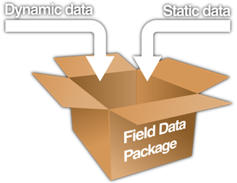

Figure ‑: Field Data Package

: Each dynamic data value carries its own value, source, owner and timestamp.

Each time an item in the dynamic data changes (with interval dependent on protocol), the item is overwritten accordingly and distributed over the network ten times a second.   
This updated data package is then compared with other versions of the same package on the network.

FT NavVision® uses timestamps & sources to compare the values in the various package-versions, and selects the highest priority value as new value. The source of the value determines which new value is selected, followed by the timestamp of the readout.

Note that the procedure above is also used for distributing & synchronizing configuration (i.e. the static data of a field) over the entire network.

This means that any adjustment to a field configuration can be performed on any alarm panel with sufficient rights, and is picked up by all FT NavVision® servers/clients.

After the current value is updated, it is compared with the alarm levels set in the static data of the same package. If the current value does not fall within the parameters set by these alarm levels, FT NavVision® registers an alarm by setting the corresponding status in the dynamic data (e.g. too low alarm status) to "True" (with "False" meaning this status is currently not applicable).  
The data package is then again distributed over the network, and the cycle repeats itself.

# Topology

Whether you are working on a new build or doing a refit, the starting point of the system will be the topology. You will need to question what you would like to see and\or control where. It will be good to start out with a simple sketch where the first important thing is that you have some sort of GA for the ship.

With this GA you start out with deciding where you would like to have a monitor. Just start with the simple monitor, the specifications will be decided on later. To show how easy it can be done we start with a single hand-drawn sketch (see Figure 2‑1).

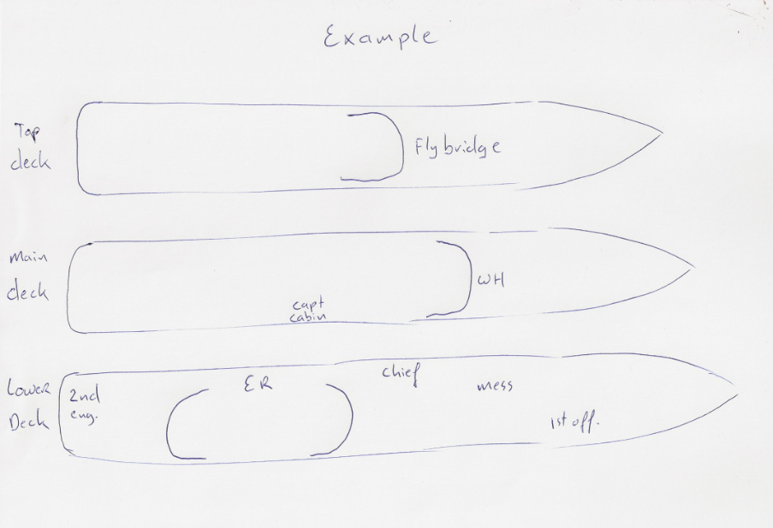

Figure ‑: topology 1

## Screens and PC’s

So here we go and make the decision on who is entitled to see the AMCS. The first two will be clear I guess:

* Engine room
* Wheelhouse

They definitely get a screen to see the AMCS. So in this case we will draw a screen there. Next we’ll be asking if they use the flybridge a lot to see if they need monitoring there as well.

Depending on the ship being under class and assuming that they need duty selection we have a mandatory screen in the public spaces and assumingly two duty screens in the chief cabin and in the 2nd engineer cabin.

The captain doesn’t need a screen but just wants one and to keep everybody satisfied he wants one for the 1st officer as well. So we end up with the following screens:

* Engine room
* Wheelhouse
* Flybridge
* Messroom
* Chief engineer
* 2nd engineer
* Captain
* 1st officer

So we end up with the next drawing (see Figure 2‑2).

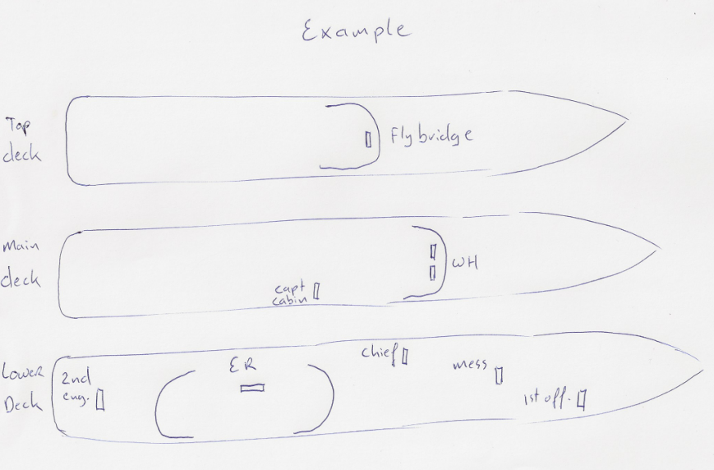

Figure ‑: topology 2

So now we know where we need to put screens, it is time to think about what kind of PC we want there.

For example the wheelhouse needs two screens and is of high importance for the monitoring system. We would definitely put a PC there. This also goes for the engine room.

The Flybridge is used pretty often so we can choose to put a PC here. But while there is often a space deficit on a flybridge it is more likely that we connect that screen to the wheelhouse pc through a KVM switch.

The rest of the screens can be duty alarm panels because they are mostly used for duty selection. Maybe the mess can be fitted with a normal screen with pc but that is up to the owner.

So we now have the pc’s as we would like them (see Figure 2‑3).

Of course you can draw it more professional than I show you in my example, but you get the feeling on the method.

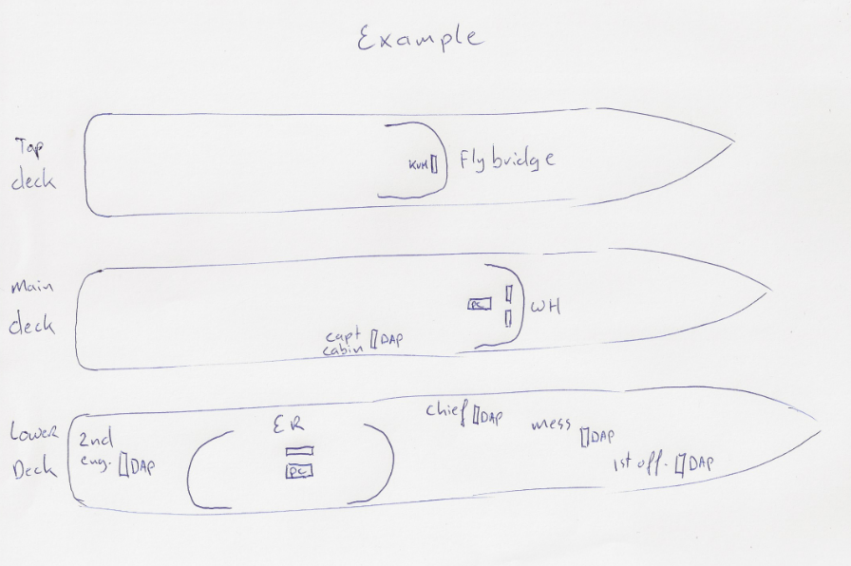

Figure ‑: topology 3

## What information do you need and how to get it

Now we are going to make it a bit more professional. We need to know what they want to be monitored and/or controlled on the system. Depending on what kind of installation you are doing, the information you need to gather differs. The installation can be needed for a new build, a refit or an extension of an existing system or even as small as just one screen added to an ECR. The way you gather information is somewhat the same but differs in a few sections.

### New build

For a new build we usually start in the beginning of the process. There should be intense communication with the yard and all adjacent parties. First of all there need to be decided what kind of system there will be required. Will it be a monitoring system? Will it also control part of the system etc. collect all data that is available about how the system need to work, which sensors will be used, all documentation of these sensors and which cabling will be necessary. Mostly all these information will be at hand and be discussed over at several meetings. Collect as much information as possible. If the system is much alike an earlier project, make sure you get all these data as well.

### Refit

For a refit much of the above applies as well. An advantage is that, most likely, there will be schematics available about the old system. This can be used as a blueprint for the FT equipment list. A disadvantage is that you will have to make sure that everything will fit in the old spaces and that you will have to check all the current wiring if it is up to date. Although mentioned, this lies outside the scope of this training, but it is surely a point of attention. If sensors are renewed or changed, collect all the appropriate data.

*: We will explain how to integrate it into a sensorlist in another part of the training.*

## Topology drawing

After gathering all the information it is time to put it to paper. FT NavVision® has a specific way of drawing the topology. As you can see in the example (see Figure 2‑4) we draw the PC’s, the screens, switches and all interfaces, based upon their actual location and connected with the right cabling

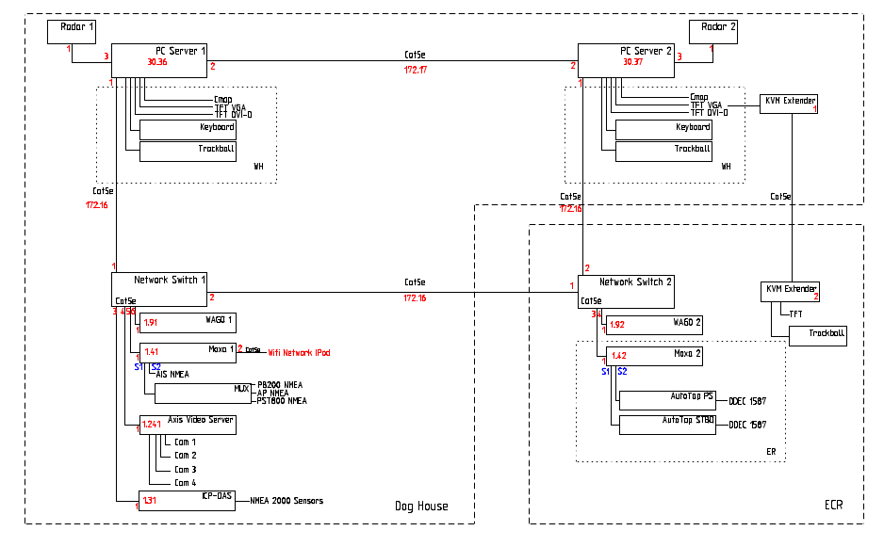

Figure ‑: topology drawing

This way we have a pretty good overview on the system’s topology. Also it is quite easy to discuss the topology with the client and you’ll have a good starting point for building the sensorlist.

# Network

## Introduction

FT NavVision© is a redundant AMCS that uses, at minimum, Cat5E cables to connect the system. This redundancy is obtained by the use of multicast and an independent ring of Lan-cables. The goal is that the main workstations can gain access to every place in the system through different routes, this way preventing a total system breakdown when one cable breaks. With FT NavVision© it is possible that when two or more cables get broken or a part of the system shuts off, the rest of the system still will function properly.

## Ring network

Looking at the topology drawing again you will notice that we create a kind of ring consisting of all the PC’s and switches. We use two separate lan-ports on each device so we can make two separate rings. We call it the up-and down network. These networks both have a different IP-range. We use the IP-ranges 172.16.x.x and 172.17.x.x. of course we can extend these ranges for taller ships if we need more ranges. We can go on with 172.18.x.x and so on.

When we start out with distributing IP addresses we normally start at the side where the I/O are located. So normally this range will be the 172.16.x.x range. For example we have a PC with key number 5051. Than the IP on the side that leads to the I/O will get the IP address 172.16.50.51. This will probably lead to the first switch which doesn’t hold an IP-address. From there on it might lead to more switches or to another PC. This new PC will have the same IP-range but will be ending on his key number. For example 172.16.50.52.

Because this PC has only two LAN ports and we don’t want an IP-conflict, the following line from that pc will get a different IP-range. So if the new lan-port will lead to a next switch, it will get the IP-address 172.17.50.52. This way we can go on until we end at the second LAN-port of the first PC. Than we close the ring network.

In FT NavVision© we have a tab “System layout” where you can check the network. It gives you a kind of birdview of the network (see Figure 3‑1). In this example you see that the lines are purple which means that the connection has never been made. Once it is connected it will turn green and after that, when it loses connection, it will turn red.

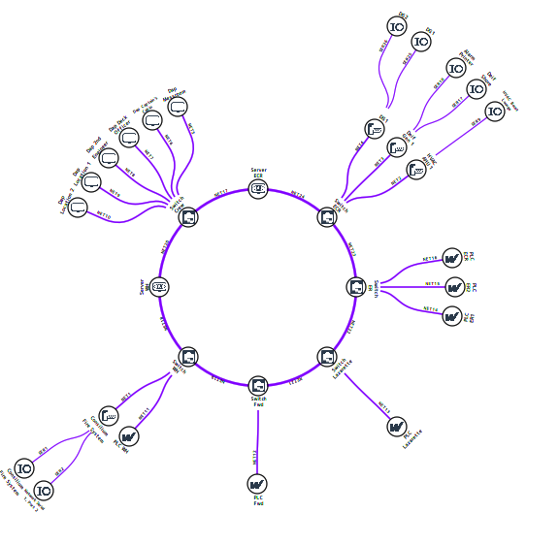

Figure ‑: System layout

*: this layout can be even more extensive depending on the scale of the system. This lies outside the scope of this training.*

## Materials

Although you are free to use the materials and brands that you prefer, it is highly recommended that you use the minimum-requirement list that is available at Free Technics. This is merely a guideline for the range in which you have to choose your materials e.g. if you use lan-cable, take at least Cat5E quality.

# Interfaces

## Introduction

FT NavVision© can handle a lot of incoming and outgoing signals. Not all these signals can be handled via the standard COM-ports that a PC has. To “change” these signals to an appropriate type we make use of all kind of interfaces. These interfaces change the type of signal to one that we can process wilt the available ports on the PC i.e. LAN or COM-port. In newer installations we hardly use the COM-ports anymore. We change all the system to LAN and put it, via a switch, inside the network.

## Sorts of interfaces

The Moxa UC-7110 series of RISC-based communication platforms (see Figure 4‑1) are ideal for your embedded applications. UC-7110 comes with two RS-232/422/485 serial ports and dual 10/100 Mbps Ethernet LAN ports to provide users with a versatile communication platform.

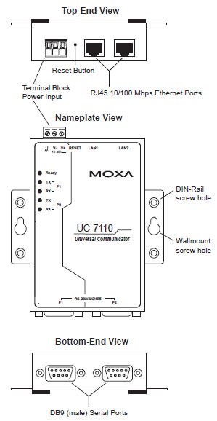

Figure ‑: Overview (MOXA)

The ICP DAS i-7540D CAN-Ethernet gateway is a solution that enables CAN networks to be coupled together over the Internet/Ethernet, whereby remote monitoring and control is possible. The CAN-Ethernet gateway controls networked communication and makes a transparent CAN-based application interface available to the user.

The device supports a transparent, protocol-independent transfer of the CAN messages, thus allowing its implementation into a wide range of possible applications. Furthermore, the CAN-Ethernet gateway can be used with various higher layer CAN protocols (e.g. CANopen, DeviceNet or other proprietary protocols).

Figure 4‑2 shows the CAN-Ethernet gateway application architecture.

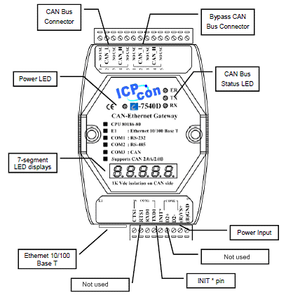

Figure ‑: Pin assignment

## Documentation

In the FT NavVision® documentation you can find all these manuals for the interfaces that we use. As well hardware as software manuals are provided.

# System Configuration

## Introduction

The Operators Workstation Human Machine Interface (HMI) function enables to visualize the actual state of a physical platform object, by color and/or shape animation. Moreover as soon as an undesirable platform state is detected the relevant operator will be notified by means of an audible alarm signal.   
Messages concerning the alarm are displayed by the alarm presentation. The HMI also supports remote platform control signals in case operators control the platform via the Operator PC (OPC). The FT NavVision® HMI consists of the following features i.e.:

## Taskbar

FT NavVision® main User Interface (UI) element is the taskbar, positioned on top of the main screen. The taskbar is home to the shortcuts to various viewers and time.

In addition, whenever an alarm is registered, the right most portion of the taskbar turns a bright red and shows a list of the alarm(s) currently active. A single click on this portion links to the extensive alarm viewer showing the data belonging to each alarm item such as time, alarm group, status and duration.



Figure ‑: FT NavVision® taskbar

Features:

* Scroll feature (hold or click the mouse pointer on the taskbar arrow until the desired button is found)
* By clicking a particular button, you will open the corresponding module/viewer
* In case more than one monitor (MTR) on one PC is used, a monitor for a particular viewer must be selected. If no screen is chosen, a vacant screen will be selected at random.
* The selected and activated button will obtain a green spot, to indicate that the corresponding module is activated
* A module can be closed by clicking the corresponding button again. In case one screen is used, a module will close by clicking a new button
* When several screens are available, it will be possible to display the viewers of the modules on these screens;
* On the right-hand side of the taskbar there is an alarm zone that will display the active alarms. One or two alarms will directly be visible. In case there are more than two active alarms, they will alternately appear (scroll) on the taskbar;

The alarm report screen can be opened by clicking the alarm zone.

### Taskbar development

In the future the taskbar will be a bit smaller. We used to have a static viewer for all kind of circumstances. This gets more and more integrated into the mimic pages where you can freely design your own viewer. In the long run, only a view icons will remain.

## Tools

The tools taskbar is where you can find all the configuration options. Once opened you will see a menu at the left where all these options come available.

## Users 1

The tab “Users” features all the adjustments to set up different access control for different users. The main reason for user access control is protecting the system. By limiting the user changing the configuration settings etc. the chance of disturbing system operation is limited as well.

Basically only three users are available. Administrator is the user status for Free Technics and its representatives. This login has all the rights available. This is logical because at commissioning and installation you need to be able to alter all the settings.

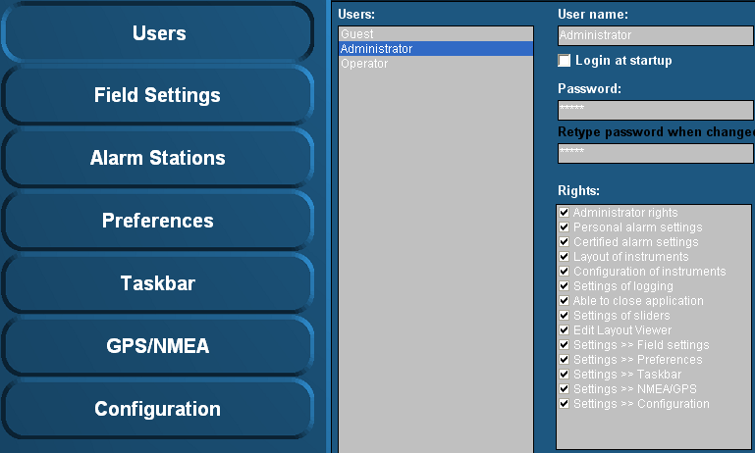

Figure ‑: Users

### User name

This is a box that shows the active user and his rights.

### Login at startup

Tick this box to set the default user at startup (default operator).

### Password

*: the user name “Administrator” is always password protected (standard this is “admin”).*

If a password is required please type password here. When changing the password or typing the password for the first time, retype password at next field “retype password when changed”.

### Rights

Rights can be set (by check mark) for each user. Rights are divided in several subgroups. Each user can have one or more rights. By putting a check mark you can set the rights.

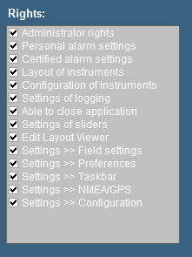

Figure ‑: Rights

|  |  |
| --- | --- |
| **Rights** | **Explanation** |
| Administrator rights | The right to change settings and user settings |
| Personal alarm setting | Set personal alarms directly in the instruments |
| Certified alarm setting | Set certified alarms in Field settings > Alarms |
| Layout of instruments | Change layout of instruments (i.e. unit, analogue-digital etc.) |
| Configuration of instruments | Change fields that instruments are representing |
| Settings of logging | Make logs of incoming data (see “Configuration > Field settings > log”) |
| Able to close application | Decides if the button to close FT is available |
| Settings of sliders | Allow setting of sliders in layout viewer |
| Edit layout viewer | Makes it possible to change the layout viewer |
| Settings > Field settings | Allows changing the field settings (see “Tools > Field Settings”) |
| Settings > Preferences | Allows changing the preferences (see “Tools > Preferences”) |
| Settings > Taskbar | Allows changing the taskbar (see “Tools > Taskbar”) |
| Settings > NMEA/GPS | Allows using “Tools > NMEA/GPS” tab |
| Settings > Configuration | Allows changing of configuration settings |

* **Administrator rights**All rights.
* **Operator rights**  
  Via “Setting > Preferences”, you are allowed to change time and language, ships heading reference and SMS service.   
  This can be extended with additional rights depending on what is needed.

*:   
Under “Operator rights” you will NEVER get the rights as mentioned below.*

* Administrator rights
* Certified alarm setting
* Configuration of instruments
* Settings of logging
* Settings of sliders
* Edit layout viewer
* Settings > Field settings
* Settings > Configuration

### Add / Remove

Via the “Add / Remove” buttons a user can be added or removed.

For example you need to add a user for the shipyard or the installation company. Click “Add” and fill in a new user name. For the removal of a user, click the user then click “Remove” and acknowledge.

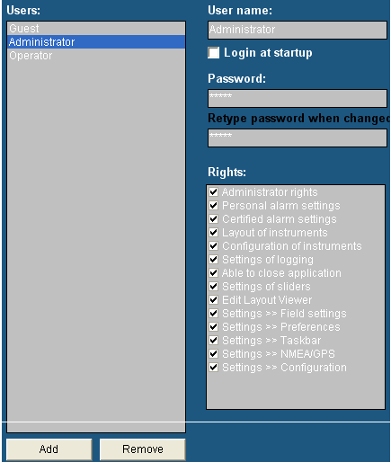

*:*

*Setup the new user direct at the beginning of the setup. In this way the user will get access to all settings and adjustments. If you set a new user after you’ve finished installing and adjusting the system, this will result in an empty user.   
All adjustments you’ve made are not visible. You can get the adjustments you made to appear in the new user by copying the content of the “administrator.ini” to the new user ini-file (i.e. shipyard.ini). For more information please refer to section “Adjusting ini-files”.*

Figure ‑: Add / Remove

1 Due to improvements and changes, this article will become obsolete. It will be removed as soon as the new changes take effect.

## Field settings

Under “Tools > Configuration > Field Settings” you’ll find the tools to adjust and fine-tune on field label basis. For every I/O you attach a label onto you will find different ways of tuning in each tab of field settings.

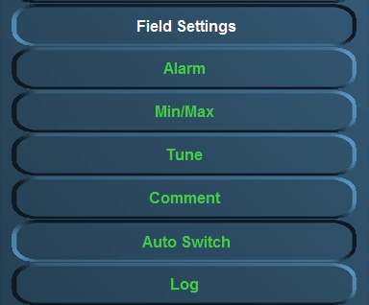

Figure ‑: Field settings

The following settings are available:

* **Alarm**  
  Settings of user alarms, warning alarms, critical alarms, Alarm group settings, SMS settings, inhibit settings
* **Min/Max**  
  Setting of instrument range, zone marking, default unit and filter
* **Tune**  
  Setting of tuning table, see results and sender
* **Comment**  
  Check and change group label, group label logbook, field label and field label instrument
* **Auto Switch**

Make various in-and outputs react on each other.

* **Log**  
  Setting and enabling/disabling logging for each field label.

### Alarm

Choose the field you would like to change the alarm settings for (e.g. “Steering and Propulsion >Rudder > Angle”).   
Depending on the field selection, a number of field settings are available. In this example the following settings are allowed:

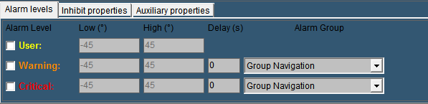

Figure ‑: Alarm settings

An alarm field as this “rudder alarm” is not set as alarm by default. It gives an analogue value )in this case within the range -45 degree and +45 degree. Now within this range you can set a few alarms. The settings that can be altered are the following:

#### Alarm levels

* + **User**Via this check box the user alarm settings are set. In this example you can set the alarm threshold (low and high). Usually you will not set them here but in the instrument itself (it is a user alarm) but you can check and/or change them here
  + **Warning**   
    The warning alarm is a dedicated alarm to warn the user when certain thresholds are exceeded. This alarm can have a dedicated delay and a dedicated alarm group (i.e a high or low alarm).   
    Choose these thresholds widely within the boundaries of the capabilities of the attached device (check specific manual for the values)
  + **Critical**To set the critical alarm thresholds (i.e. too high or too low) (check specific manual for these values).
* **Delay(s)**The time (in seconds) the system will wait before it will show the specific alarm that is triggered. This is necessary if a hysteresis is needed (i.e. a bilge alarm that is on the edge of the alarm by the rocking of the ship, will not go of all the time if you put in a delay)
* **Alarm Group**Here you can put the alarm in a specific group. By putting it in a group you can manage the rights of different users on whether they can silence or acknowledge these alarms. For more detailed information please refer to chapter “Alarm stations”.

By example it will look like this (see Figure 5‑7).

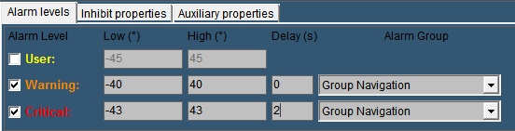

Figure ‑: Alarm example

The next tab is for the inhibit properties.

#### Inhibit Properties

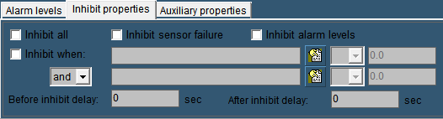

Figure ‑: Inhibit Properties

There will be certain occasions where you do not want the alarm to go off. For example an oil pressure alarm from an engine will normally also be in alarm when the engine is shut down. This is not wanted as an alarm. Or when a sensor is broken and there is no time to repair it for a while, it will be easier to inhibit the “Defect Alarm” of this sensor until you have time to repair it.

* **Inhibit All:**

This checkbox is used to inhibit all the alarms from this particular sensor. Especially when the sensor is defect, it will come in handy. In the alarmpage (See Alarmpage) you will constantly see that the sensor is inhibited, so you won’t forget.

* **Inhibit Sensor Failure**Some sensors (i.e. 4-20 mA) tends to go a little bit out of range. Normally this will be no problem. However if a 4-20 mA sensor drops below 4 mA or goes higher than 20 mA, FT NavVision® will see this as a sensor failure and will give an alarm. If you think it is just the range of the sensor that is giving the problem, you can check this box to stop these alarms.
* **Inhibit Alarm Levels**If you have set alarm levels as mentioned in “Alarm Levels” And you need them out for a while, check this box.
* **Inhibit When**

In the earlier mentioned oil pressure alarm, you don’t want that alarm to go off when the engine is not running. This is where “Inhibit When” will help. In the inhibit properties of that particular sensor you mark the checkbox. Now you search the belonging engine running field in the box next to that, by clicking the tab besides that. While you want the alarm to be inhibited when the engine is not running, in the next field you choose “<” from the dropdown menu. Finally you set an amount (in this case 0.5) in the adjacent field. Now, when the engine is not running, the alarm will not sound. (see Figure 5‑9). Finally you can choose an additional field (And/Or) to specify even further. For example you can use the Shaft Speed RPM as backup. (see Figure 5‑10).

“Before Inhibit Delay” and “After Inhibit Delay” are delays to catch up for irregularities in the sensors behavior.

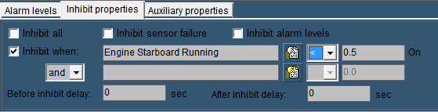

Figure ‑: Inhibit When

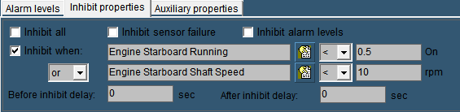

Figure ‑: Inhibit When 2

 *If you specify just one inhibit field, make sure the “and/or” box is set to “and”. Otherwise the alarm field will not work.*

#### Auxiliary Properties

* **Alarm Sound:**

Obsolete

* **Send SMS When Alarm Active**If you have the SMS Alert License you can tick this checkbox to send a text message to your phone, every time the alarm is triggered.
* **Alarm On Request Timeout**Especially valves will have a long time to open or close. You can set a timeout on the time to get an alarm if the conditions aren’t met in the given time.
* **Alarm When Not Ready**

If the sensor is equipped whit an output to state that it is not ready, tick this checkbox to get an alarm.

### Min/Max

Under “Tools > Field Settings > Min/Max” (see Figure 5‑11) the instrument boundaries can be set. For example the “Engine 1 Oil Pressure” instrument can be set as follows:

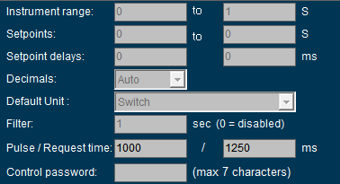

Figure ‑: Min/Max settings

#### Instrument range

The instrument range field is used to define the measuring range (scale) of the instrument.   
For example: the indicator below is scaled from 0 to 30 bar.

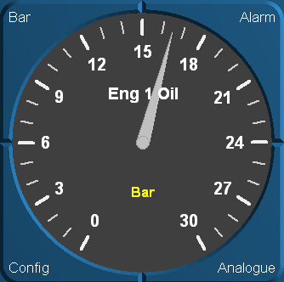

Figure ‑: Engine 1 oil pressure indicator (0 - 30 bar)

*:*

*In order to detect and identify a deviating function, make sure that all instrument (in a column or row) pointers are aligned to the same position (default mode).  
Check the default values of each instrument and set the instrument range accordingly.*

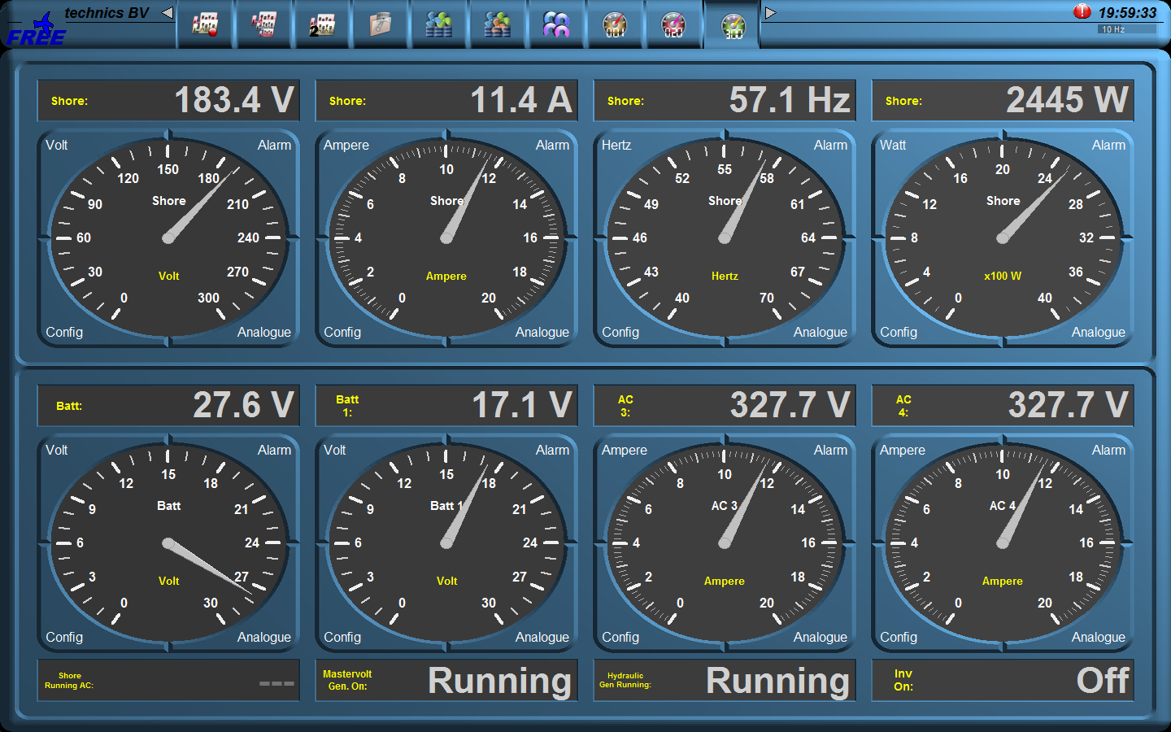

Figure ‑: Instrument pointers

By aligning the instrument pointers to the same position (see Figure 5‑13) it will be easier to detect a deviating function.

#### Setpoints

If the sensor values and their working ranges are known is working, you can set different setpoints. It puts a grid over the desired values on the instrument, to verify if the readings are correct, or it gives a min and max setpoint to give an alarm for example

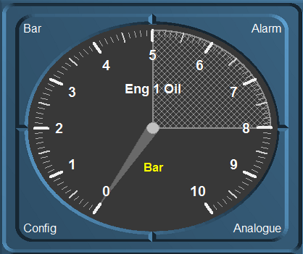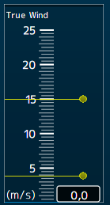

Figure ‑: setpoints

#### Setpoint delays

Sometimes it is not desirable to get the setpoint alarm directly (i.e. oil pressure). In that case you can set delays for the setpoints.

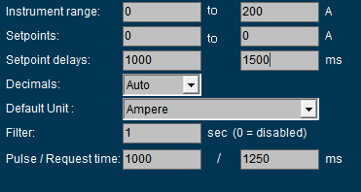

Figure ‑: Setpoint delays

#### Decimals

Defines how many decimals you want to show after the comma.

#### Default unit

At startup each instrument will show the unity in which it will display the data. Depending on the sensor type select the desired unity (see Figure 5‑16).



Figure ‑: Default unit

*: in a mimic you can choose a secondary value to show in the mimic itself. See chapter about mimics*.

#### Filter

If an instrument reading seems to be a little erratic, you can select a higher number (see Figure 5‑16) to dampen the movement of the instrument pointer.

### Pulse/Request time

Defines how long the pulse will be or how long a request will wait for a responseTune

#### Tune table

The “Tune table” settings allows the user to fine-tune the output of a sender.  
 **Example 1: Sensor value too low.**  
In such a case you must change the second input value. You can change the input value as follows:Input value= 0.8 → Real value = 1.  
The statement above implies that for every input of 0.8 bar the output (actual reading) is 1 bar. In other words, any sensor input value of 4 bar corresponds with an instrument reading of 5 bar.   
  
**Example 2: Sensor value too high.**Change the input value as follows:  
Input value = 1.2 → Real value = 1.  
The statement above implies that for every input of 1.2 bar the output (actual reading) is 1 bar. In other words, any sensor input value of 5 bar corresponds with an instrument reading of around 4 bar.   
For threshold values you can change the first input value. If the pressure indication has to start later than given, you can put in “Input value = 0.2 → Real value = 0”   
This will make the instrument starts displaying as soon as the threshold of 0.2 bar has been reached. This can be accomplished the other way around.

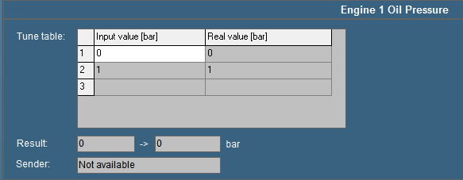

Figure ‑: Tune table

#### Result

The “Result” box displays the exact incoming measuring data. The second box displays this data via the respective instrument that is connected to the sensor.   
If for example the sensor gives a pressure (bar) output for every 20 mV, the real time result may read “100 → 5 bar” (see Figure 5‑17). As a result the sensor reads “100 mV” and indicated as “5 bar” on the instrument.

*:*

*Values may differ per sensor type.*

#### Sender

The “Sender” box (see Figure 5‑18) displays the device name where the data is coming from. If the sender field shows “Not available” indicates that that the sensor isn’t giving any data (for a reason why it is not giving data, check the troubleshooting section).   
Other items you can see in the box “sender” are: NMEA, Wago, Serial, Modbus, Calculated in, etc. this gives you an indication where the signal is coming from.

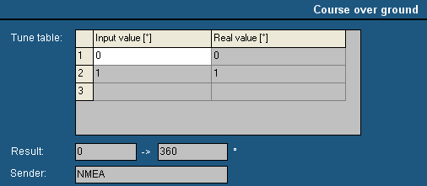

Figure ‑: Sender box

### Comment

In the “Comment” section you can change the names of different fields to get an overall clarity. These names can be changed for the clarity in an instrument or a logbook if the sensor has an explicit name. Sometimes you have to use an auxiliary field when the name for that sensor is not available.

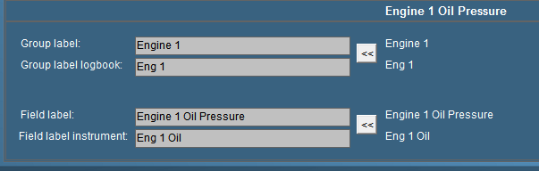

Figure ‑: Comment

#### Group label

Via “Group label” you can assigns a field to a specific “Alarm” group. The name is written in full so there will be no misunderstanding. It is especially handy if you have different sensors, which are arranged in different groups. Once grouped, you change them in “Group label”. For more detailed information concerning alarm groups please refer to chapter “Alarm stations”.

#### Group label logbook

is the label that is shown in the logbook (see chapter logbook). To save space you type an abbreviation of the group label. This is helpful to check in the logbook. All the alarms in the Logbook will have a group available so it is distinct where to place the alarm.

#### Field label

The field label is the exact indication of the sensor. For every sensor in FT NavVision® you need a unique ID. That ID is the field label. Whether it is already preprogrammed or you rename an auxiliary field, that field label represents from then on the sensor. Knowing this, NavVision can connect this sensor to an instrument, calculate with it etc. mostly you will see the representation of this field label in the Wago (see Wago), but it is possible you find it in other, programming or calibration files.

#### Field label instrument

The name of the sensor showed in the instrument is set in the field label instrument. While there isn’t always that much space in an instrument, we use an abbreviation of the “Field label”. If you have to make up a name yourself be sure to choose a name that is representing the sensor and is clear, even in the abbreviation.

### Auto Switch

#### General

Under auto switch you can automate some of the actions of I/O in a decent easy manner, without knowledge of PLC programming. It is used to make small automations within the program.

#### Autoswitch Method

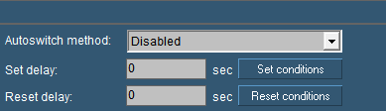

Figure ‑: Autoswitch

|  |  |
| --- | --- |
| **Autoswitch option** | **Explanation** |
| Autoswitch Method | Here you choose how the switch works  Disabled: not working  Set over Reset: Set is standard position  Reset over Set: Reset is standard position  Mimic Switch: for use in a mimic without attached sensor |
| Set Delay | Delay time for Set condition |
| Reset Delay | Delay time for Reset condition |
| Set conditions | Set conditions on how to react (see Figure 5‑21) |
| Reset conditions | Set conditions on how to react (see Figure 5‑21) |

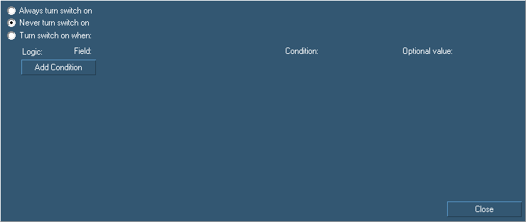

Figure ‑: Auto Switch Conditions

|  |  |
| --- | --- |
| **Autoswitch conditions** | **Explanation** |
| Always turn switch on | Switch is always on/visible |
| Never turn switch on | Switch is always off/unvisible |
| Turn switch on when | Let you add logic to turn a switch on |
| Add Condition | Alter the conditions that you need to make the switch work |

For example if you have a switch that turns on the bilge pump, you can also let it switch on when a certain event occur. So if you have a high alarm from that bilge, you can make the switch go on by saying so in the conditions field (see Figure 5‑22)

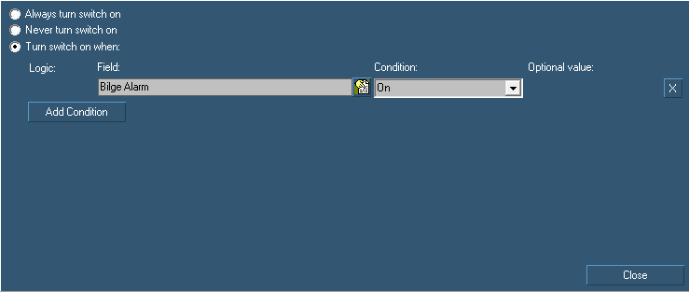

Figure ‑: Auto Switch condition

### Log

For troubleshooting and examination purposes you can log all the fields. All the data coming in on each specific field can be saved to a log file.

Go to “Tools > Field Settings > Log” and choose the right field (e.g. Engine 1 Oil Pressure).

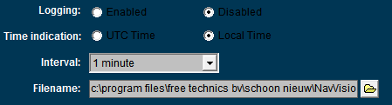

Figure ‑: Logging

#### Logging

Choose whether to enable or disable the logging on this field.

#### Time indication

Universal time or local time

#### Interval

Depending on the data on the field you can choose an interval her form 1 second to 2 hours. Useless to say that the log file is getting a lot bigger at an interval of 1 second. Be very precautious when using this.

#### Filename

Here you can chose the name and place where you save the log file.

*:*

*Save the log file to D: or any other disk that FT NavVision® ® is running on. If you save the log file on to c: (the embedded disk) you lose the log every time the system starts up again.*

## Alarm stations

The installation on board can be divided into different parts (alarm stations) which all can have different rights concerning the completion of alarms. Besides that it is proficient to have different rights for different groups onboard it is also prescribed by organizations such as Lloyds Register etc. there are preset names to choose from.   
These groups can be setup with specific alarm-rights. You can understand that the crewmess has other rights on alarms as the Engine Room or the Wheelhouse. Also the same goes for many other stations around the ship as there are the captain’s cabin, Flybridge, etc.

### Station Matrix

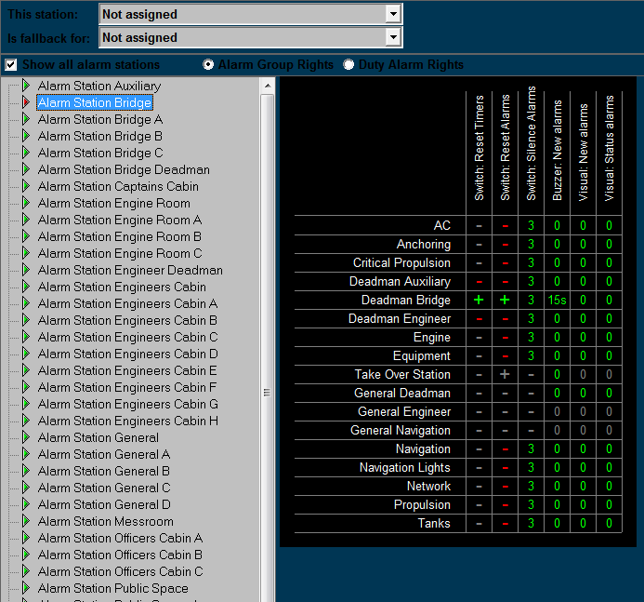

Figure ‑: Alarm stations

#### This station

Defines the station this computer is set on. All the alarm settings of that station are also valid for the PC screen you are working on. If set to “Not Assigned” no specific alarm restriction is set.   
All alarms will be visible and can be silenced or acknowledged.

#### Is fallback for

This defines which rights this computer will get once the station set in this box is not working. If this would be the wheelhouse pc it could be a fallback station for the engine room. When the engine room pc should be out for whatever reason, the wheelhouse station will take over the tasks and rights of the engine room pc. This way all the important tasks can still be handled.

*: in future releases this feature will be obsolete. By making all the stations a server that can work independently, there will be no need for this function.*

#### Show all alarm stations

Ticking this box switches between showing all, or all available Alarmstations.

#### Alarm group rights/Duty alarm rights

Choose either of these two to switch between changing alarm group rights or duty alarm rights.

#### Adjustments

On the left pane you can choose the alarm station to be adjusted. The adjustments will only be valid for that particular station. When you choose to set this station (i.e. Alarm station bridge) on an alarm panel or another Server or client, these will have the same settings automatically.

*:*

*All the settings in the diverse alarm stations will automatically be set in all the other pc’s (servers and clients) which are connected. You won’t have to change all PCs separately. On the left panel you will find all the groups that are available in the system.   
Groups that are in use by the system are shown in the right pane. Other groups will not be available. You can set the alarm options for each separate group.*

*When finished, all alarm options of each alarm group will be set within the specific alarm stations.*

The following options are available:

|  |  |
| --- | --- |
| **Alarm group option** | **Explanation** |
| Visual: status alarms | Shows any alarm even if it is acknowledged |
| Visual: new alarms | Shows new alarms for this group |
| Buzzer: new alarms | Sounds buzzer on new alarms for this group |
| Switch: silence alarms | Allows to silence the alarms for this group |
| Switch: reset alarms | Allows to acknowledge the alarms for this group |
| Switch: reset timers | Allows resetting of timers (i.e. dead man’s timer) |

#### How to set

Fields are set separately by pointing the mouse onto that field and right click it. The “Reset” fields will turn to “+” and the other fields will turn to “0” which simultaneously means that the delay is set to “0” minutes.

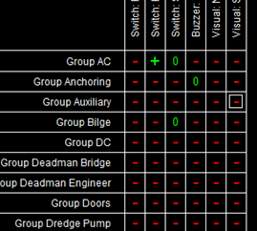

If you want to set a field to a higher delay (i.e. you want to silence an alarm for 3 minutes) you must left click the field. A menu will appear where you can change the settings including the delay time. Check “Enable the selected cells” and choose a delay time. You can choose the delay time in minutes or seconds by checking the appropriate box (seeFigure 5‑25).

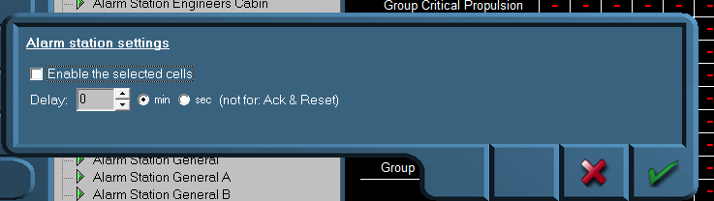

Figure ‑: Alarm station settings

In addition, you can do this for different cells at the same time, by clicking and dragging the mouse over the preferred cells (see Figure 5‑26).

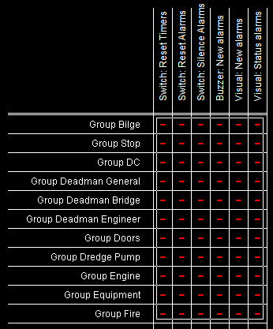

Figure ‑: Select by dragging

If you want to disable the alarm settings, deselect the checkbox “Enable the selected cells”.

#### Background

To elaborate a little bit further we will explain a bit more about the use of alarm stations. Each station will be in a particular part of the ship (i.e. wheelhouse, engine room, crewmess, chief engineer cabin etc.) All these stations have their own rights on which alarms they can hear or see and how they can act upon such an alarm. For example, the engine room is the place where all the alarms normally will be visible and almost always the only place where alarms can be acknowledged. This is because regulations require that alarms can only be acknowledged on that part of the ship where you can act upon the alarm and take precaution action on that alarm. Now in the crewmess (a public space) all kind of people have access to the workstation. It is not advisable that these people have rights to acknowledge the alarm. So in this space you can set the Alarmstation rights for the crewmess, so that they don’t have the rights to acknowledge.

You can imagine that in the wheelhouse they do not want to see all the alarms concerning propulsion etc. merely navigational alarms are mostly enough on the bridge. Here you can set the alarm stations to only show navigational alarms and not propulsion alarms.

We have developed a lot of standardized settings for different variations. Please refer to the troubleshooting manual for these examples.

#### Duty alarm rights

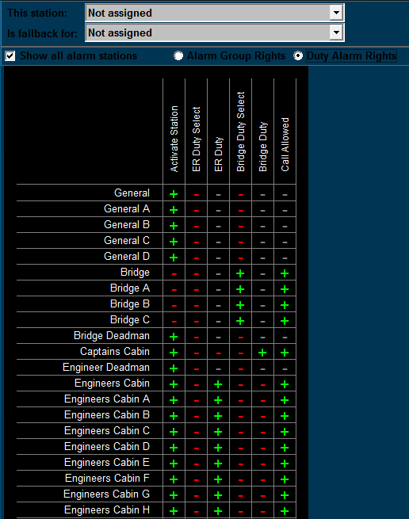

Figure ‑: Duty alarm rights

|  |  |
| --- | --- |
| **Alarm group option** | **Explanation** |
| Call Allowed | Marks if other stations are allowed to call this station |
| Bridge Duty | Marks if station can be selected for Bridge Duty |
| Bridge Duty Select | Marks if station can select bridge duty |
| ER Duty | Marks if station can be selected for ER Duty |
| ER Duty Select | Marks if station can select ER duty |
| Activate station | Marks if station is allowed to switch on or off |

### Alarm Panels

Often we use smaller panels as a workstation in diverse rooms (especially the smaller cabins and messroom) these panels are called DAP (Duty Alarm Panel). These DAP’s have to be pointed out to the system. Under Alarm Stations>Alarm Panels you can set these DAP’s (see Figure 5‑28).

|  |  |
| --- | --- |
| **Alarm group option** | **Explanation** |
| MAC | Type the MAC-address of the DAP here |
| Alarm Station | Choose which station it will represent (for alarm settings) |
| DAP Type | Choose the type of DAP in use |
| IP | IP address in range 172.xx.0.81 and so on |

*: after changing these settings choose “ accept and restart communication” to activate the changes.*

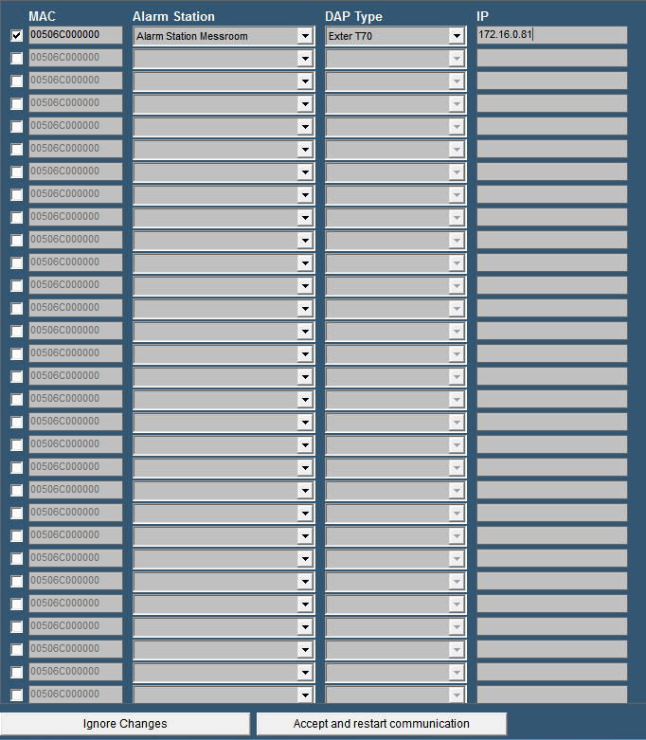

Figure ‑: Alarm Panels

### Alarm groups

In Alarm Groups you can define the looks of the DAP’s (see Figure 5‑29).

Under “duty alarm panels” you can set the rows and columns that you want to see if they are in alarm. You can choose up to 2 rows and up to 5 columns. Under “assigned alarm groups” you can define which alarm group you will see. Just click on a field and choose the specific alarm Group.

“This Station” defines the look and feel of the OWS. In default mode you have the same layout as a standard alarm page. You can also choose to only see a list of alarms or a list of alarms with the controls for silencing etc.

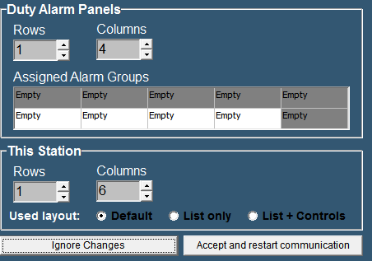

Figure ‑: Alarm Groups

*: after changing these settings choose “ accept changes” to activate the changes.*

### Alarm Settings

Here you can specify different alarm settings.

Under “Duty Alarm System” you can choose the following:

Automatic deactivate of public space When ER attended: if you do not want the alarms to sound in all the public spaces when there is someone at watch in the ER

Alert duty Cabin When ER turns unattended: To notify the person on duty that there is nobody in the ER anymore and his watch begins.

Alert Bridge when ER turns unattended: Just for convenience.

Under “Personal Alarm Settings” you can choose if the deadman timer starts again with every new alarm.

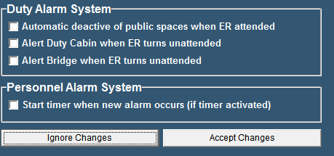

Figure ‑: Alarm Settings

## Preferences

### General

With the field “Preferences” (see Figure 5‑31), you can set several personal preferences. For example, you can set the software language, set the ships heading references as well as configure the SMS service.

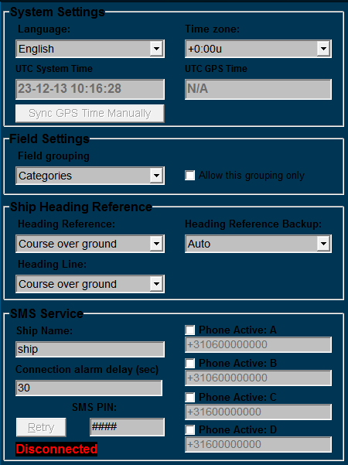

Figure ‑: Preferences

### System Settings

By clicking the “Language” arrow, all supported software languages appear.

Simply click on one of these languages to set the default language for all software modules.

By clicking the “Time zone” arrow allows you to set the relevant UTC[1] time zone.

As soon as a GPS is connected to the system FT NavVision® will use this GPS to set the time. In this case you won’t have to alter the “Time Zone” while it will be taken care of by the GPS. If you think the time is not right, you can click “ Sync GPS time manually”.

### Field Settings

Under “Field Grouping” you can choose in which order you want to see all the fields in “field settings”. You can change the order to “Categories” or to “ Alarm Groups” The last one will come in handy when you are checking whether all the fields are in the right Alarm Group.

### Ship heading reference

This option allows you to choose the default references for heading, heading backup and heading line. The options range from Auto to Course over ground, Gyro compass, true compass and magnetic compass.

### SMS service (ship name)

Ship name is used to enter your ship’s name into the software. Of course, the name is entirely your own choice and has no influence on the software’s functions.

### SMS service (phone active A,B,C and D)

*:*

*When entering a phone number always include your country code.*

Phone activate A-D are used to store the telephone numbers of one or more mobile phones you want to receive text-messages with. First, tick off the checkbox for each phone in use and enter the phone-number of your choice.

### SMS service (SMS PIN)[2]

Via the field SMS PIN, enter a personal code (any combination), used to establish a connection in between your phone and the system. The black box below shows whether a connection is established or not.

|  |  |
| --- | --- |
| **Detail** | **Description** |
| Connected | Indicates that a connection is made. Alarm messages are allowed to be sent to your mobile phone. |
| Disconnected | Indicates that no connection is made. No alarm messages to be allowed. |

## Taskbar

### General

To open the FT NavVision® ® taskbar menu, select “Tools > Taskbar”.

The taskbar menu is used to configure the taskbar.

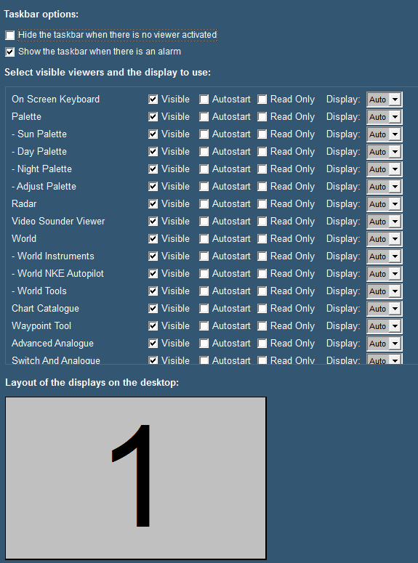

Figure ‑: Taskbar menu

The following taskbar settings are available:

|  |  |
| --- | --- |
| **Setting** | **Description** |
| Hide the taskbar when there is no viewer activated | This option allows you to hide the taskbar, in case all viewers are inactive. This function can be disabled, by moving the mouse cursor to the top of the screen. |
| Show the taskbar when there is an alarm | This option allows the taskbar to appear whenever an alarm occurs. This overrides the previous setting of the hidden taskbar. |
| Visible | This option allows you to select the availability of viewers. You can select the viewer that must be displayed and be accessible through the taskbar or not. |
| Autostart | The second option enables you to determine the viewers that automatically open at startup of the software. |
| Read Only | This option prevents people to alter settings in the viewer or mimic |
| Display | The display box defines the screen used for each viewer. The number shown symbolizes the displays as shown at the bottom of the screen. “Auto” means that it will appear at the first free screen. If there is a number, the viewer will appear on that screen. Only available if you have more screens attached. |
| Layout of the displays on the desktop | This setting allows you to show the placement of the different screens connected to your system. The display order, size and the number available for display of viewers are shown. |

#### 

## GPS/NMEA

### General

The GPS/NMEA page is merely a reference to check data. You can use it to see if data from GPS or NMEA devices is coming into the system and if the data is right.

### GPS calculates the position in/The position is shown in

These two fields can be used to change the calculating method of the GPS sets. In almost any case you can leave them as they are.

### Trace of received NMEA data

In the window below the text you will find all the NMEA data that is coming in. With the eraser you can clear the data from the window. By checking/unchecking the box from “Rx” or “Tx”you get respectively only received, only transmitted or all data.

If the string you see in the window is green, the data is recognized by FT NavVision® and can be processed. This doesn’t directly mean that the data is correct, but only that the string is sent in the right style. If the string is grey, it is no longer available or not in the correct style and won’t be processed by FT NavVision® .

*: While FT NavVision® repeats a lot of NMEA data for multiple purposes, it is wise to uncheck the “Tx” box when you are checking the incoming data.*

## Configuration

### General

Under configuration you will find all the tabs that you can use to configure and fine-tune the FT NavVision® system. Some of them are still in progress and will be available soon. You do not need them know. All the other features we will discuss here.

## License

To give rights to use a specific part of the software, FT NavVision® uses licenses to open up these parts of the software. Depending on which licenses are bought, viewers will be visible and strings will be processed (see Figure 5‑33).

Under “License” you can see which viewers, communication etc. are opened in your version. If you see a license and it is green, this means that the license is valid. If the license is red it is not valid. If there is no license and the stripes in the box are green or red it means the same, only than the license is freed up by another license (i.e. Navigation Pro license will also open up NMEA, so the stripes under NMEA will be green).

Normally you won’t have to alter anything here. Free Technics will provide you with a “Key.uc.ini” with all the necessary licenses available. The program will read the licenses from the ini-file and put them in place at startup. Sometimes however you can check here if you miss a certain viewer or if a communication protocol doesn’t seem to work. If you are missing a single license, you can fill it in here and it will be set in the ini-file as well.

*: Missing licenses are also mentioned in the logbook. Please refer to the chapter “Logbook” for more information.*

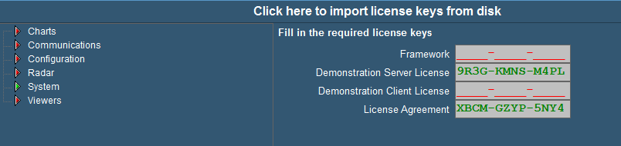

Figure ‑: License

# Platform hardware

## Serial

## General

Under “Tools > Configuration > Serial” the following menus are available;

* COM ports
* Serial LAN ports
* CAN ports
* MasterBus Devices
* Overview connected devices.

## COM ports

Under “Tools > Configuration > Serial > COM ports” (see Figure 6‑1) all COM ports as found by FT NavVision® ® become visible. At the first startup they are no COM port yet assigned (i.e. COM port menu does not show any COM port data).

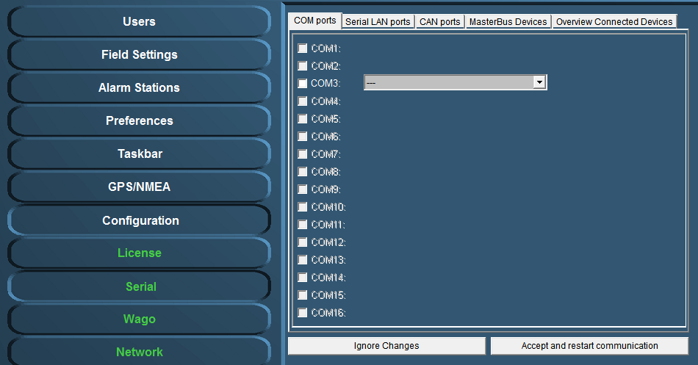

Figure ‑: COM ports

### COM port assignment

*:*

*Use the right device interface (protocol) and verify the baudrate etc.*

Check the respective wiring schematics to determine the COM port arrangement and assignment. Tick off the relevant COM port (1, 2, 3, etc.) and select the required device interface (protocol) by means of the drop-down menu (see Figure 6‑2).

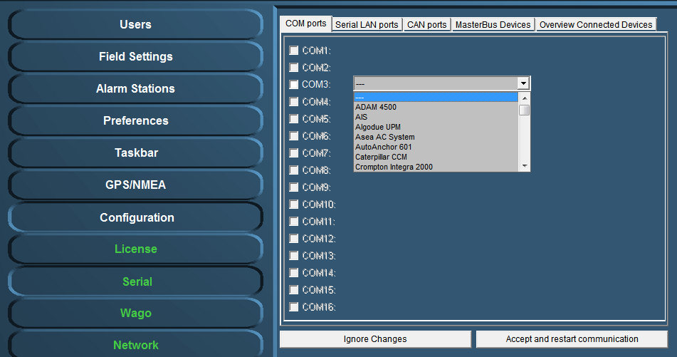

Figure ‑: Drop-down menu (device interfaces)

At completion, confirm the settings by clicking “Accept and restart communication” (see Figure 6‑2).

Check the appropriate FT NavVision® ® viewer to verify if the COM-port is correct and if there is any data communication. For example: select the “Video Sounder” viewer (see Figure 6‑3) to verify that the device interface (protocol) on “COM1” is correct. Repeat this procedure for all other listed COM ports.

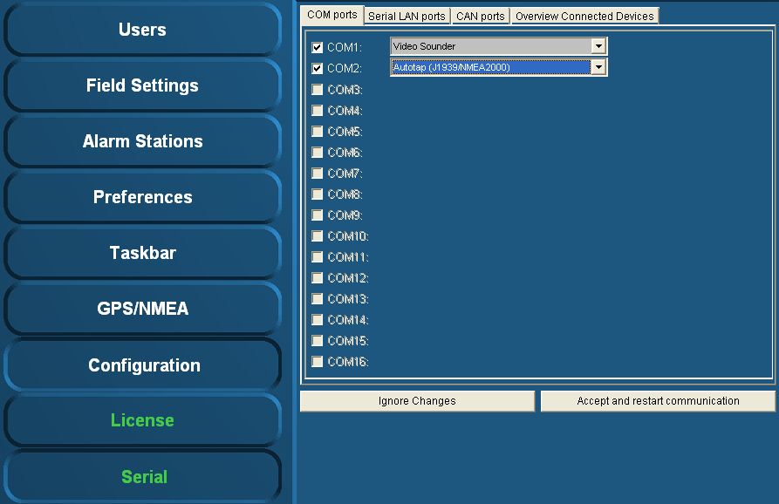

Figure ‑: COM port assignment

Additional information on the selected port can be configured by clicking on the sign behind the drop-down menu (see Figure 6‑4). A new box will open.

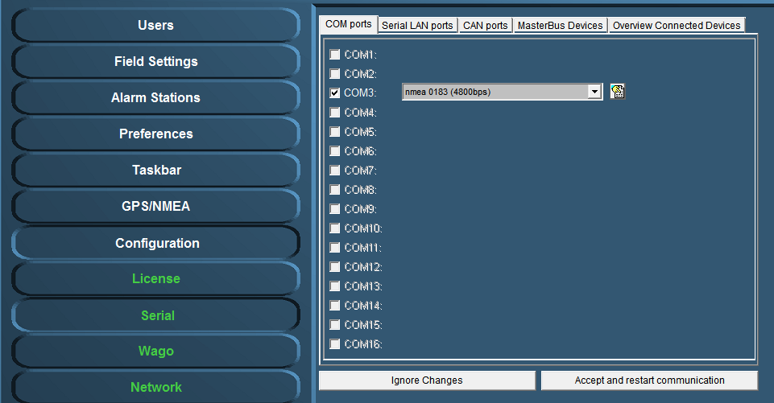

Figure ‑: additional configuration

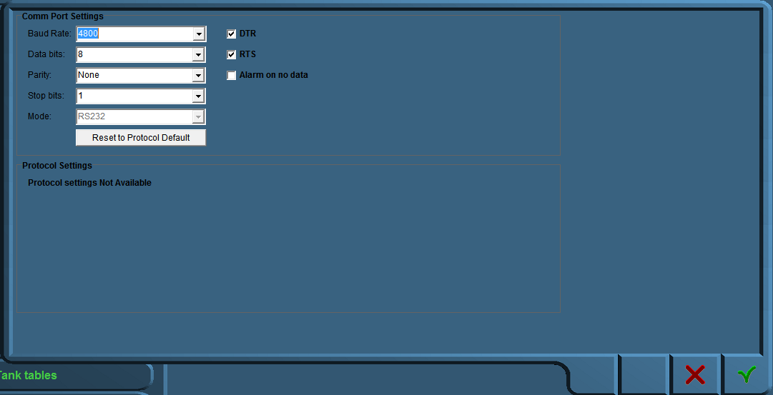

Figure ‑: Comm Port Settings

In this additional configuration menu (see Figure 6‑5) you can force all the settings for the regarding Comm port. The following fields apply:

* Baud Rate: Set the appropriate baudrate (see manual attached device)
* Data Bits: The number of data bits in each character can be 5 (for Baudot code), 6 (rarely used), 7 (for true ASCII), 8 (for any kind of data, as this matches the size of a byte), or 9 (rarely used). 8 data bits are almost universally used in newer applications. 5 or 7 bits generally only make sense with older equipment such as teleprinters.
* Parity: The parity bit in each character can be set to none (N), odd (O), even (E), mark (M), or space (S). None means that no parity bit is sent at all. Mark parity means that the parity bit is always set to the mark signal condition (logical 1) and likewise space parity always sends the parity bit in the space signal condition. Aside from uncommon applications that use the 9th (parity) bit for some form of addressing or special signalling, mark or space parity is uncommon, as it adds no error detection information. Odd parity is more common than even, since it ensures that at least one state transition occurs in each character, which makes it more reliable. The most common parity setting, however, is "none", with error detection handled by a communication protocol.
* Stop Bits: Stop bits sent at the end of every character allow the receiving signal hardware to detect the end of a character and to resynchronise with the character stream. Electronic devices usually use one stop bit.
* Mode: In mode you can set the protocol that the serial port is using to communicate. Refer to your device for the proper protocol. You can choose between RS232, RS422 and RS485. In some occasions you can’t choose Mode cause the interface protocol can only work in a predefined Mode (i.e NMEA is always RS232).
* DTR: Data Terminal Ready, indicates presence of DTE to DCE (set high or low)
* RTS: Request to send, DTE requests the DCE prepare to receive data (set high or low)
* Alarm on no data: Gives an alarm when there is no data on the Comm port
* Reset to protocol default: Resets standard configuration for chosen protocol

## Serial LAN ports

Under “Serial LAN ports” (see Figure 6‑6) the attached serial LAN device can be addressed and when necessary be calibrated.

The following fields are available;

* Serial LAN server
* Type (serial LAN server)
* IP address
* MAC address
* Data/control port
* LAN1 and LAN2

After installation a calibration procedure must follow, to ensure that the LAN device will function properly.

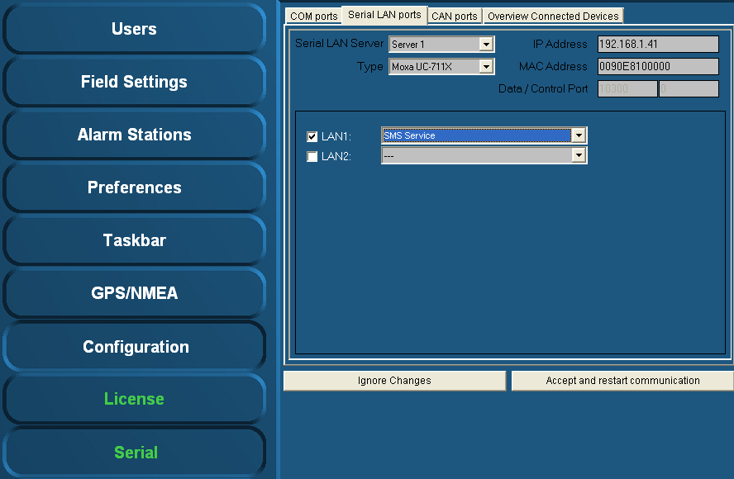

Figure ‑: Serial LAN ports

## Serial LAN server

Under “Serial LAN ports > Serial LAN server” (see Figure 6‑7) the server to be assigned can be selected. In addition under “Type” the LAN server type can be selected.

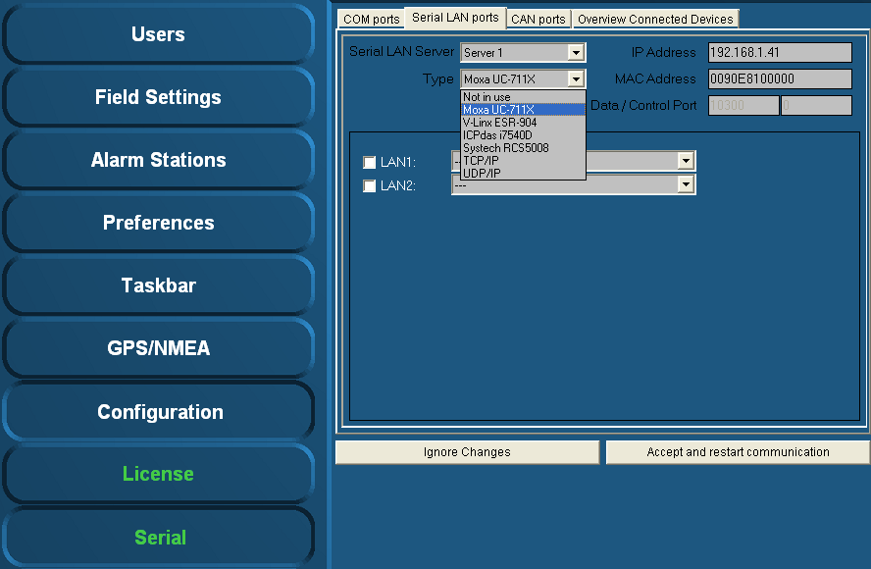

Figure ‑: Type (Moxa)

### Type (Moxa UC-711X)

The Moxa is found under “Type” > “Moxa UC-711X” (see Figure 6‑7).   
Fill in the IP address of the Moxa unit under “IP Address” (use same range as the PC i.e. 172.16.x.x, for Moxa the last digits are in the 40 range).   
The very first connected Moxa unit is set to IP address 172.16.1.41 and the next available to 172.16.1.42 etc.

*:*

*The MAC address can be found on the sticker underneath the unit.*

For the Moxa unit it is necessary to use a MAC address specified under “MAC Address”.

If necessary, verify the LAN1 and/or LAN2 settings and choose the appropriate device interface / protocol (see chapter 6.3.1).

To confirm the settings, click “Accept and restart communication” and verify if the serial data is working within FT NavVision® ®.

### Type (V-Linx ESR-904) *Obsolete*

The V-Linx is found under “Type” > “V-Linx ESR-904” (see Figure 6‑8).   
Fill in the IP address of the V-Linx unit under “IP Address” (use same range as the PC i.e. 172.16.x.x, for V-Linx the last digits are in the 40 range).  
The very first connected V-Linx unit is set to IP address 172.16.1.41 and the next available to 172.16.1.42 etc.

*:*

*Please be aware that multiple units (i.e the Moxa’s) will operate within the same IP address range (172.16.1.4x). Use different IP addresses, otherwise the system may not function properly.*

Verify the LAN1 - LAN4 settings (if available) and select the appropriate device interface / protocol (see 6.3.1).

To confirm the settings, click “Accept and restart communication” and verify if the serial data is working within FT NavVision® ®.

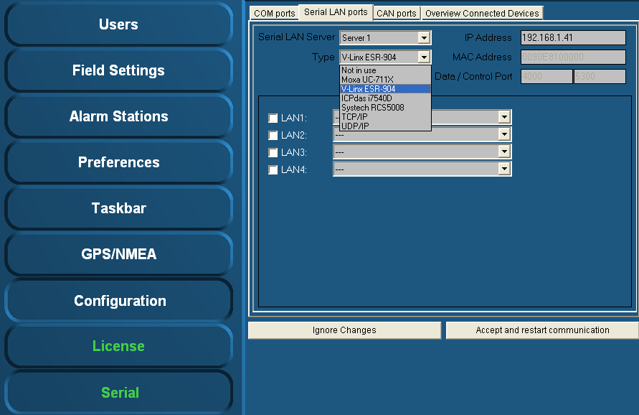

Figure ‑: Type (V-Linx ESR-904)

### Type (ICPdas i7540D)

The ICPdas is found under “Type” “ICPdas i7540D” (see Figure 6‑9).   
Fill in the IP address of the ICPdas server under “IP Address” (same range as the PC i.e. 172.168.x.x, for ICP the last digits are in the 30 range).

The very first connected ICP is set to IP address 172.16.1.31 and the next available to 172.16.1.32 etc.

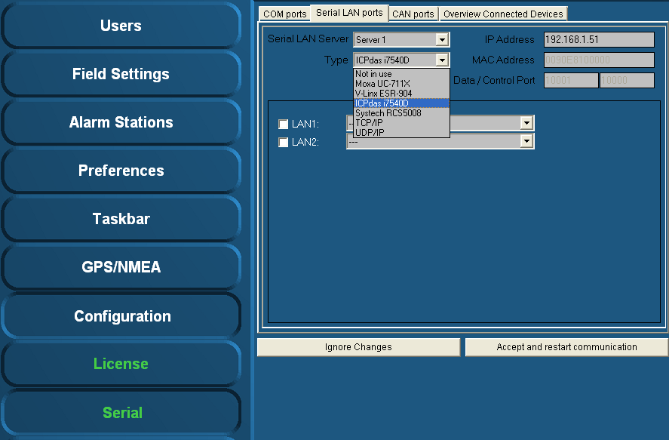

Figure ‑: Type (ICPdas i7540D)

Verify the LAN1 and LAN2 settings (if available) and select the appropriate protocol (see 6.3.1).

To confirm the settings, click “Accept and restart communication” and verify if the serial data is working within FT NavVision® ®.

## CAN ports

Under “Serial > CAN ports” the following menus are available:

* Interface
* Standard
* IP
* Group.

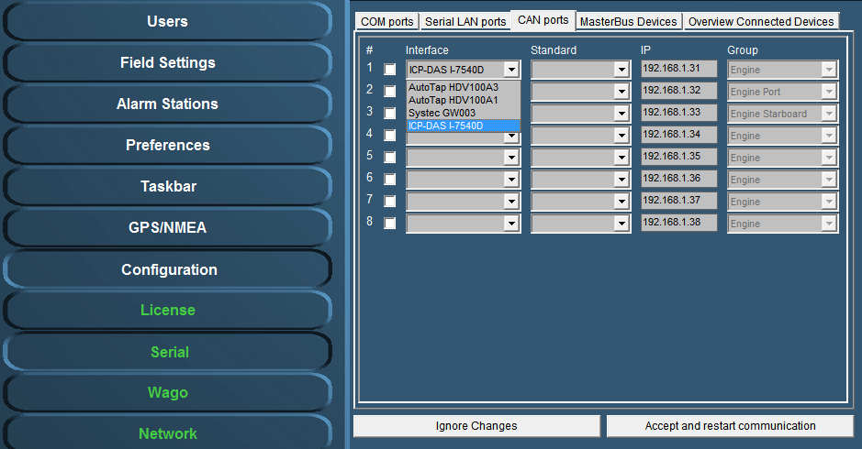

Figure ‑: Interface

Under interface you can choose different kinds of Can-interfaces. The most used one is the ICP. If you come across an older version, you can choose it here. (see Figure 6‑10).

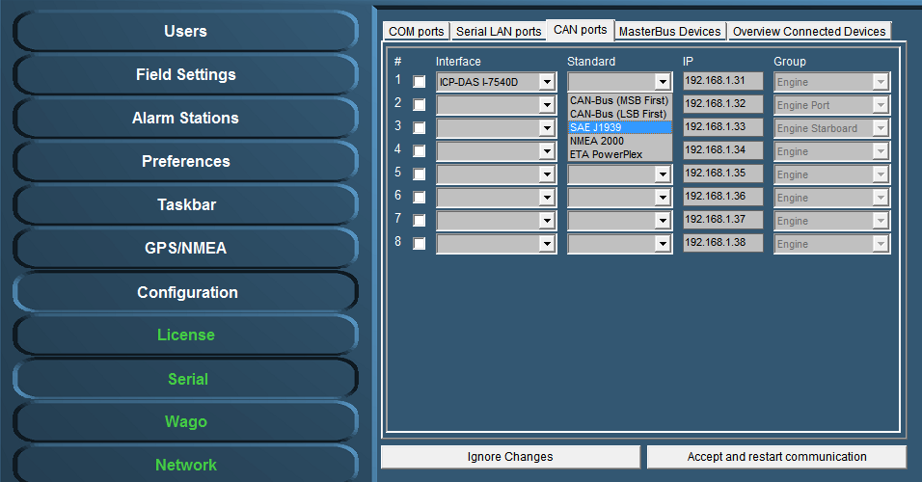

Figure ‑: Standard

* Under Standard you choose the protocol you want to use with the interface (see Figure 6‑11). Most widely used are the NMEA 2000 and the SAE J1939. Which to use is depending on your attached protocol.
* Under IP you can select the right IP address that reflects the connected ICP for example. You can best leave it as it is by default (which will become the 172.16.1.x range). For information on how to set the right IP-address in the ICP, please refer to the ICP installation manual.
* The group you choose reflects under which group the information will be stored in NavVision. If you, for example, want the information from the interface to show up under Engine Port, you select that under Group (see Figure 6‑11).
* After each change you need to hit “Accept and restart communication” to save it to the system.

## Overview connected devices

*:*

*The installation of serial devices may require some calibration. For example, it may be possible that you need to make some adjustments in the “INI-files”. For more detailed information on this subject please refer to Free Technics .*

Under “Serial > Overview Connected Devices” (see Figure 6‑12) an overview of the connected devices is shown.

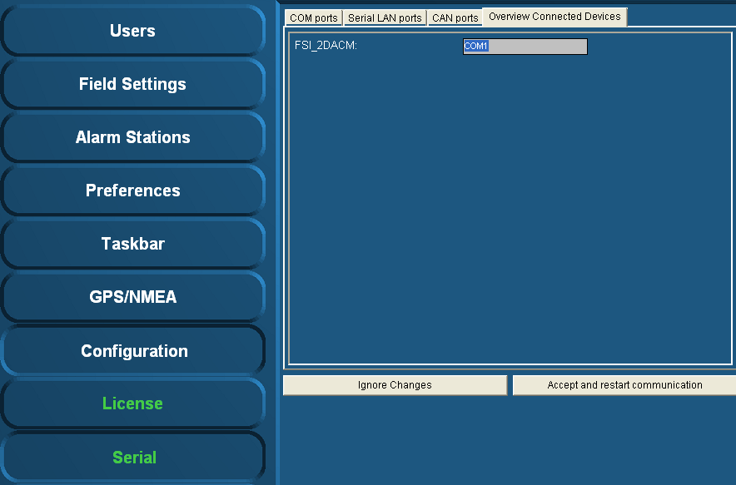

Figure ‑: Overview connected devices

## IP-Address standardization

For standardization purposes the same IP-addresses are used throughout each system. In the table below you’ll find the IP-addresses (standard protocol) for most instruments.

|  |  |
| --- | --- |
| **Detail** | **IP-Address** |
| PC I/O | 172.16.x.x (172.16.24.35 for key number 2435) |
| PC I/O next ring | 172.17.x.x (172.17.24.35 for key number 2435) |
| Duty Alarm Panels  (DAP) | Using range x.x.1.8y  Depending on the network connected, this will result in:  DAP 1: 172.16.1.81  DAP 2: 172.16.1.82  DAP 3: 172.16.1.83 |
| Serial LAN servers | Using range 172.16.1.4x (attached to I/O subnet 172.16) INT 1: 172.16.1.41 INT 2: 172.16.1.42 INT 3: 172.16.1.43 |
| Wago | Using range 172.16.1.9x (attached to I/O subnet 172.16) Wago substation 1: 172.16.1.91 Wago substation 2: 172.16.1.92 Wago substation 3: 172.16.1.93 |
| CAN-Interface | Using range 172.16.1.3x (attached to I/O subnet 172.16) CAN interface 1: 172.16.1.31 CAN interface 2: 172.16.1.32 CAN interface 3: 172.16.1.33 |
| Axis | Using range 172.16.1.24x (attached to I/O subnet 172.16) Axis cam server 1: 172.16.1.241 Axis cam server 2: 172.16.1.242 Axis cam server 3: 172.16.1.243 |

# Wago

## General

Under “Tools > Configuration > Wago” (see Figure 7‑1) all detected and connected Wago devices become visible including the server to which they are connected to.   
You can check the MAC-address and see if the Wago is connected or not.

In general, by means of the sensor list changes are made. But for minor changes or to improve the control of the device, please refer to this menu.

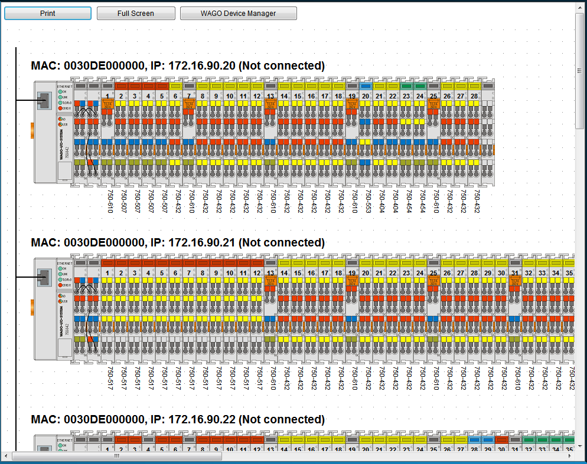

Figure ‑: Wago configuration

|  |  |
| --- | --- |
| **Detail** | **Description** |
| Print | Print the separate Wago-layouts for your convenience |
| Full Screen | Shows the Wago-layout full screen |
| Wago Device Manager | Opens a new window where you can set specific configuration settings |

When you click on a Wago, it will expand and show you the separate slices with the connected fields (see Figure 7‑2). Here you can fine-tune the selection, troubleshoot problems and calibrate sensors.

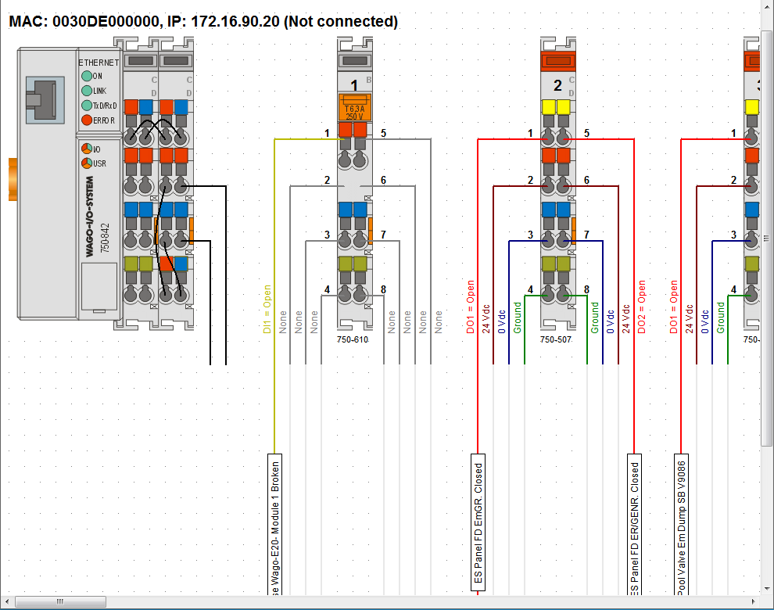

Figure ‑: Wago expanded view

## Adding a field to the Wago

If you want to add a new field to a Wago slice, just click on the field name box of the specific slice. If there was not already a field attached, the box will be blank (named sensor). By clicking it you will open a new window that shows all the fields within FT NavVision® (see Figure 7‑3)

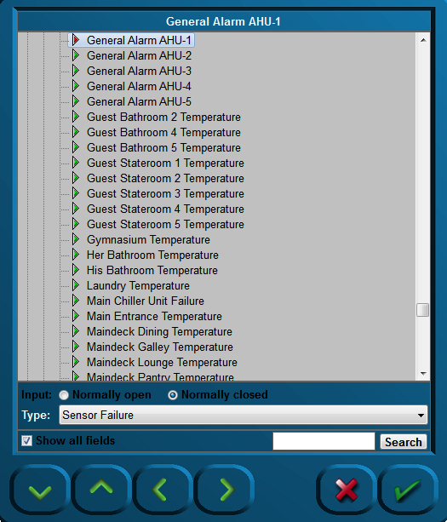

Figure ‑: Sensor-window

The following choices are possible:

|  |  |
| --- | --- |
| **Detail** | **Description** |
| Input | NO or NC |
| Type | The behavior of the field (see 7.3) |
| Show all fields | Toggling between all fields and fields available |
| Search | Search for a specific field |

## Wago “Type” explanation

The Type architecture needs some extra explanation. Each field in FT NavVision® has its own behaviour. It can be an alarm, a status, or an analogue value. Sometimes you need to give a field a specific task. As add-on to its original task, or if the field is just a standard field.

By default the sensor will have “standard” as its type-value. This will set the behavior to the standard mode of the field. The choices you have and their behavior will be explained in the next paragraph.

### Type and behavior

Under “Type” (sensor type) a variety of sensor types can be chosen. The most commonly used types are described.   
Click the arrow button of the dropdown menu to open the sensor type list (see Figure 7‑4).

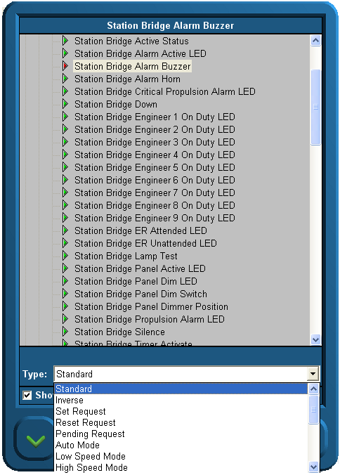

Figure ‑: Sensor type list

#### Alarm

If the connected field isn’t a specific alarm field (see “Field Settings > Alarm”) it is possible you still like it to act as an alarm. Just set the type to Alarm.

#### Alarm Buzzer

If a field has to react at the same pace as an alarm buzzer, you can choose this type. If you, for example, put it on an output, You can let a lamp blink as the alarm goes off.

#### Alarm Status

Sometimes you need to feed a led-board to show all the alarms on a separate place. With type Alarm Status, you can set a field to set high if this field is in alarm. This way you can feed a led-lamp.

#### Auto

Auto is used in the combination Auto/Manual. If you choose this type, you can see when a sensor is ready to be controlled through FT NavVision® .

#### Closed

Does the same as the set/reset request but then on the DI. Look at a specific sensor to find out that it is functioning. When on is detected it knows the position is closed.

#### Failure

It is the same as status, but in this case mostly used as a setting to check whether the sensor is in failure. It is used to set failure status on bulb failure or as general alarm from attached devices.

#### High

See low alarm.

#### High Level

See low alarm.

#### Impulse

If an impuls relay is connected to a DO you don’t want to generate a constant voltage. Put the status on “Impuls Relay” and the DO will give a short pulse when triggered.

#### Lamp

If, in addition to FT NavVision® , you also need to show the lights on an analogue panel, it is wise to give all the lights the type “Lamp”. This way it will be possible to use the lamp test function. By using this function, all the fields with “Lamp” as type will lit up once the lamp test is pressed. Also you can use it to test the real lights. When pressing the lamp-test button you can check all the bulbs.

#### Low

If the connected FT-field isn’t a specific alarm field (see “Field Settings > Alarm”) it is possible you still like it to act upon an alarm. For example if you have the field “Fresh water level” you could like to have an alarm when the tank is almost empty. Here is where you can put the status to “low alarm”. The system will identify it as an alarm field and will consequently show the alarm on the alarm panel and logbook. Note that it states “ext.” on the alarm panel to indicate that it is an external alarm.

#### Low Level

See low alarm.

#### Off Lamp

See Lamp.

#### On Lamp

See Lamp.

#### Open

Does the same as the set/reset request but then on the DI. Look at a specific sensor to find out it is off. When off is detected it knows the position is opened.

#### Pending

Used on a DO. Once selected it gives a signal as long as the particular task is not fulfilled. I.e. in a mimic you can show by a blinking icon that the action is still taking place.

#### Pulse

When a sensor needs a short pulse instead of a steady signal, use Type “Pulse”.

#### Push

Same as Switch, but then used as a second type for the same sensor. Also used to control the sensor through a mimic button.

#### Ready

When the sensor is ready for use, “ready” will get high.

#### Remote

Used in conjunction with Local. To see if the sensor can be controlled locally or remote.

: local is at the sensor and remote is in FT NavVision® .

#### Request

See Switch.

#### Reset (Request)

*:*

*Does not function without Digital In (DI) status.*

The “Reset request” signal output in general is a Digital Output (DO).

Once selected, a request will be set to the attached sensor (e.g. a valve or other device that can be steered to open), and it will stay set until it gets a status back that the request is fulfilled. Needs to be combined with a DI where the status of the sensor will be connected to (i.e. open/close).

#### Running

DI that is coming from the sensor to show that it is running. Used to measure the total time etc.

#### Running Hours

Internal calculation. Once the sensor is high, this field will start the count for running hours based upon the time that the sensor is high (also when switched on but not running, so less accurate).

#### Set (Request)

*:*

*Does not function without Digital In (DI) status.*

The “Set request” signal output generally is a digital output.  
Once selected, a request will be set to the attached sensor (e.g. a valve or other device that can be steered to open), and it will stay set until it gets a status back that the request is fulfilled. Needs to be combined with a DI where the status of the sensor will be connected to (i.e. open/close).

#### Standard

This is the standard setting. Via this setting nothing extra will be added to the field. Leave it on standard if nothing else is required or if you don’t know.

#### Standby

See Ready.

#### Status

Is general used on DI. If you need to know the status on an attached sensor but that sensor is in use by the PLC-program, you can use status in the Wago configuration. Now it reads the status of the sensor without interfering with the PLC-program.

#### Switch

When a switch is connected to a DI (i.e. an external pushbutton) you must set the status to switch. A box will appear which reads “request”. Now Wago will know that it has a switch connected and will act accordingly. If this status isn’t set upon a hardwired button, this button will not work.

#### Timeout

Some sensors, i.e. valves, have a separate connection to show that the action has timed out. When not available use Timeout as type. If no signal is coming back (DI) within a certain amount of time, it will give a timeout.

#### Too High

See low alarm.

#### Too High Level

See low alarm.

#### Too Low

See low alarm.

#### Too Low Level

See low alarm.

## Wago Device Manager

Under “Configuration > Wago > Wago Device Manager” the following window appears:

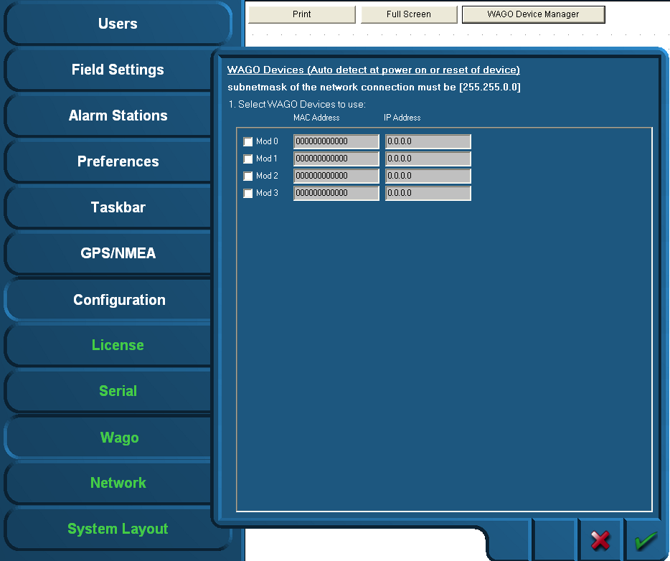

Figure ‑: Wago Device Manager

When the devices are correctly installed and connected, the respective MAC addresses will be shown via the “Wago Device Manager” window. The “Mod0” and others that are found are shown green. If a Wago is specified with an IP address and there is no connection, the Text will be red. (see Figure 7‑6)

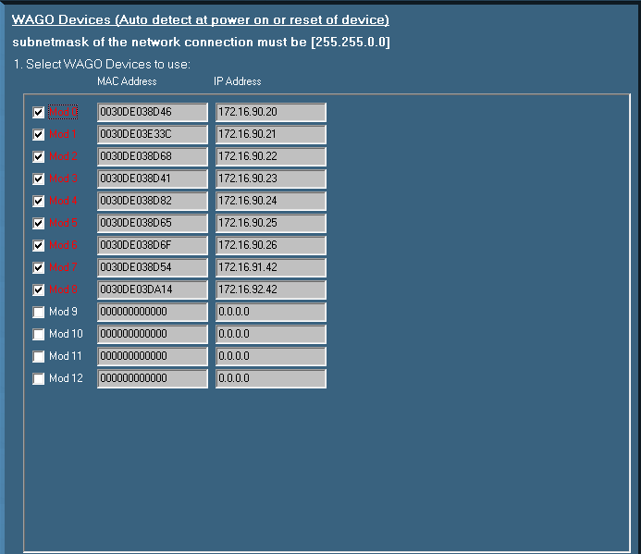

Figure ‑: Device Manager

If the MAC addresses does not show, it is possible that there is no connection with the specific Wago or the Wago devices need to be restarted. This can be accomplished by

* Disconnecting electrical power from the Wago device for a short period of time
* By pushing down the operating mode switch (see Figure 7‑7).

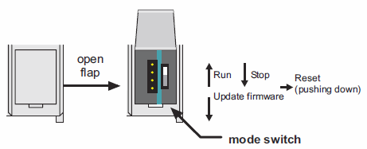

Figure ‑: Operating mode switch (Wago)

The operating mode switch (see Figure 7‑7) is a push/slide switch with 3 settings and a hold-to-run function.

|  |  |
| --- | --- |
| **Operating mode switch** | **Function** |
| From center to top position | Activate program processing (RUN) |
| From top to center position | Stop program processing (STOP) |
| Lower, bootstrap | For original loading of firmware, not necessary for user |
| Push down (i.e. with screwdriver) | Hardware reset.  All outputs and flags are reset; variables are reset to 0 or to FALSE or to an initial value.  Retain variables or flags are not changed.  The hardware reset can be performed with STOP as well as RUN in any position of the operating mode switch! |

If the device manager shows a MAC address, check this against the MAC address on the head station on the Wago. If it is right, click the check box.

Fill in the IP address the Wago device (must be in the same range as the PC, i.e. 172.16.x.x).  
For Wago the last digits are in the 90 range. The very first connected Wago will be set to 172.16.1.91 and the next available to 172.16.1.92 etc.

Confirm the settings by clicking the “OK” button. The screen will show the connected Wago devices, their respective MAC addresses, their given IP addresses and the server they are connected to.

Free Technics

Technical & customer support **The Netherlands**

Free Technics B.V.

Eikenlaan 259J

2404 BP, Alphen aan den Rijn

The Netherlands

Telephone: +31 172418 890

Fax: +31 172418 899

www.freetechnics.eu

1. UTC = Universal Time Coordinated
2. Functionality only applicable with SMS hardware module + license